


DemandIQ-
Industrial Procurement Intelligence Platform

Prepared by: Abhinav Singh
Revision Date: June 2026

Version: 1.0

Table of Contents

1. Introduction
1.1 Purpose of the User Manual
1.2 Project Overview
1.3 Objectives
1.4 Scope
1.5 Target Audience
2. System Requirements
2.1 Hardware Requirements
2.2 Software Requirements
2.3 Required Python Libraries
2.4 Installation Commands
3. Development Environment Setup
3.1 Anaconda Installation
3.2 Python Installation Verification
3.3 Jupyter Notebook Setup
3.4 Installation of Required Libraries
3.5 Project Directory Structure
3.6 Running the Application
3.7 Verification of Successful Setup
4. System Architecture
4.1 Architecture Overview
4.2 Application Workflow
4.3 Data Flow
4.4 Intelligence Modules
4.5 Dashboard Architecture
4.6 Visualization Layer
4.7 System Output
5. Project Structure
5.1 Overview
5.2 Dashboard Module
5.3 Data Processing Module
5.4 Validation Module
5.5 Machine Learning Module
5.6 Visualization Module
5.7 Procurement Intelligence Module
5.8 Module Interaction
5.9 Benefits of Modular Design
6. Dataset Preparation
6.1 Supported File Formats
6.2 Dataset Requirements
6.3 Mandatory Columns
6.4 Recommended Dataset Structure
6.5 Sample Dataset
7. Data Validation and Preprocessing
7.1 Dataset Validation
7.2 Missing Value Handling
7.3 Duplicate Detection
7.4 Data Cleaning
7.5 Dataset Diagnostics
8. Automated Target Detection
8.1 Demand Target Detection
8.2 Cost Target Detection
8.3 Safety Target Detection
8.4 In-House Cost Detection
8.5 In-House Capacity Detection
8.6 In-House Safety Detection
9. Machine Learning Framework
9.1 Automated Model Selection
9.2 Regression Models
9.3 Classification Models
9.4 Performance Evaluation
9.5 Feature Importance Analysis
10. Demand Intelligence Module
10.1 Module Overview
10.2 Input Parameters
10.3 Demand Prediction Workflow
10.4 Generated Outputs
10.5 Performance Metrics
10.6 Interpretation of Results
11. Cost Intelligence Module
11.1 Module Overview
11.2 Input Parameters
11.3 Cost Prediction Workflow
11.4 Generated Outputs
11.5 Performance Metrics
11.6 Interpretation of Results
12. Safety Intelligence Module
12.1 Module Overview
12.2 Input Parameters
12.3 Safety Classification Workflow
12.4 Generated Outputs
12.5 Safety Risk Interpretation
13. Procurement Intelligence Module
13.1 Procurement Intelligence Overview
13.2 Supplier Competition Analysis
13.3 Procurement Score Calculation
13.4 Procurement Situation Analysis
13.5 Procurement Mode Recommendation
13.6 Supplier Recommendation Engine
13.7 Procurement Intelligence Dashboard
14. Dashboard User Guide
14.1 Launching the Application
14.2 Uploading Datasets
14.3 Automatic Target Detection
14.4 Manual Target Configuration
14.5 Running Procurement Analysis
14.6 Viewing Results
15. Dashboard Pages
15.1 Enterprise Overview
15.2 Demand Intelligence Page
15.3 Cost Intelligence Page
15.4 Safety Intelligence Page
15.5 Procurement Intelligence Page
15.6 Model Performance Page
15.7 Dataset Intelligence Page
16. Reports and Visualizations
16.1 Demand Prediction Charts
16.2 Cost Prediction Charts
16.3 Feature Importance Analysis
16.4 Supplier Ranking Analysis
16.5 Procurement Score Distribution
16.6 Procurement Situation Distribution
16.7 Procurement Mode Distribution
17. GitHub Repository Management
17.1 Repository Setup
17.2 Commit Process
17.3 Push Process
17.4 Version Control Workflow
18. Deployment Guide
18.1 Deployment Overview
18.2 Deployment Prerequisites
18.3 GitHub Repository Configuration
18.4 Streamlit Community Cloud Deployment
18.5 Deployment Verification
18.6 Deployment Workflow
18.7 Post-Deployment Monitoring and Maintenance
18.8 Deployment Benefits
19. Troubleshooting
20. Frequently Asked Questions (FAQ)
21. Conclusion

1. Introduction

1.1 Purpose of the User Manual
This User Manual provides comprehensive guidance for the installation, configuration, deployment, and usage of the Industrial Procurement Intelligence Platform. The document is intended to assist developers, analysts, and end users in understanding the platform architecture, machine learning workflow, dashboard functionalities, procurement intelligence modules, and deployment procedures.

1.2 Project Overview
The Industrial Procurement Intelligence Platform is an AI-powered decision-support system developed to assist procurement and supply chain professionals in making data-driven procurement decisions. The platform integrates Demand Intelligence, Cost Intelligence, Safety Intelligence, and Procurement Intelligence into a unified framework capable of analyzing procurement datasets, generating predictive insights, evaluating suppliers, and recommending optimal procurement strategies.
The platform utilizes machine learning techniques to automate demand forecasting, cost prediction, safety classification, supplier evaluation, procurement scoring, and procurement mode recommendation. Interactive dashboards provide visual insights and support enterprise-level procurement decision making.

1.3 Objectives
The primary objectives of the Industrial Procurement Intelligence Platform are:
- Automate procurement data analysis.
- Predict future demand using machine learning models.
- Estimate procurement costs accurately.
- Assess supplier safety performance and risk levels.
- Generate intelligent supplier recommendations.
- Recommend procurement strategies based on operational conditions.
- Support in-house versus external procurement decisions.
- Provide a centralized dashboard for procurement intelligence.

1.4 Scope
The scope of the platform includes procurement data preprocessing, automated target detection, machine learning model training, supplier intelligence generation, procurement optimization, and dashboard-based analytics. The system supports industrial procurement operations by integrating multiple intelligence modules within a single platform.
The platform is designed for manufacturing, supply chain, procurement, and industrial organizations seeking data-driven procurement planning and supplier management capabilities.

1.5 Target Audience
This manual is intended for:
- Procurement Managers
- Supply Chain Analysts
- Data Analysts
- Manufacturing Engineers
- Business Intelligence Teams
- Project Developers
- System Administrators
- Internship Project Evaluators
A basic understanding of procurement processes, machine learning concepts, Python programming, and dashboard applications is beneficial for effectively utilizing the platform.

2. System Requirements

2.1 Hardware Requirements
The Industrial Procurement Intelligence Platform is a Streamlit-based web application that can be executed on a standard personal computer.
Minimum Requirements:
- Processor: Intel Core i3 / AMD Equivalent
- RAM: 4 GB (8 GB Recommended)
- Storage: 1 GB Free Disk Space
- Display Resolution: 1366 × 768 or higher

2.2 Software Requirements
The following software was used during the development and testing of the platform:

Software |  | Version
Operating System | Windows 11
Python | 3.11.9
Jupyter Notebook | 7.4.5
Streamlit | 1.45.1
Git | 2.49.0
Google Chrome | Version 137 or Later
2.3 Required Python Libraries
Library | Version
pandas | 2.2.3
numpy | 2.2.6
scikit-learn | 1.6.1
xgboost | 3.0.2
plotly | 6.1.2
streamlit | 1.45.1
joblib | 1.5.1
openpyxl | 3.1.5
matplotlib | 3.10.3

2.4 Installation Command
Install the required libraries using:
pip install pandas numpy scikit-learn xgboost plotly streamlit joblib openpyxl matplotlib
Or
pip install -r requirements.txt
After successful installation, the application can be launched using Streamlit and accessed through a web browser.

3. Development Environment Setup

3.1 Anaconda Installation
The Industrial Procurement Intelligence Platform was developed using the Anaconda distribution. Anaconda provides Python, Jupyter Notebook, and package management tools required for machine learning and dashboard development.
Installation Steps:
- Download Anaconda from the official Anaconda website.
- Run the installer and complete the installation.
- Launch Anaconda Navigator after installation.
- Open Anaconda Prompt and verify the installation using:
conda --version
A valid version number confirms successful installation.

3.2 Python Installation Verification
The platform was developed using Python 3.11.
To verify the installed Python version, execute:
python --version
Expected Output:
Python 3.11.x

3.3 Jupyter Notebook Setup
Jupyter Notebook was used for dataset exploration, preprocessing, feature engineering, and machine learning model development.
Jupyter Notebook can be launched through:
Anaconda Navigator → Jupyter Notebook → Launch
or
jupyter notebook
The notebook interface will open automatically in the default web browser.

3.4 Installation of Required Libraries
Install the required project dependencies using:
pip install -r requirements.txt
Alternatively, install the required packages individually:
pip install pandas numpy scikit-learn xgboost plotly streamlit matplotlib openpyxl joblib
To verify successful installation:
pip list

3.5 Project Directory Structure
The project should be organized as follows:
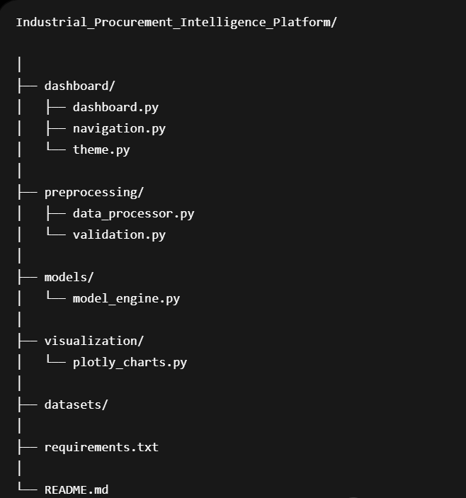
Figure 3.1: Project Structure Tree
The dashboard module contains the Streamlit application, navigation system, and visual theme. The preprocessing module performs data validation and preparation. The model engine executes machine learning workflows, while the visualization module generates procurement analytics charts.

3.6 Running the Application
Open Anaconda Prompt and execute the Streamlit application:
streamlit run dashboard/dashboard.py
After successful execution, Streamlit starts a local server and opens the dashboard in the default web browser.
Default URL:
http://localhost:8501

3.7 Verification of Successful Setup
The setup is considered successful when:
- The Streamlit dashboard launches without errors.
- Dataset upload functionality is available.
- Navigation options are displayed correctly.
- Demand, Cost, Safety, and Procurement Intelligence modules are accessible.
- Procurement analysis can be executed successfully.
Once these checks are completed, the Industrial Procurement Intelligence Platform is ready for use.

4. System Architecture

4.1 Architecture Overview
The Industrial Procurement Intelligence Platform follows a modular architecture consisting of data preprocessing, machine learning, visualization, and dashboard layers. The platform processes procurement datasets, generates intelligence through machine learning models, and presents actionable insights through an interactive Streamlit dashboard.
The architecture is designed to support automated procurement analysis, supplier evaluation, and procurement decision-making.

4.2 Application Workflow
The platform operates through the following workflow:
- Dataset Upload
- Dataset Validation
- Data Preprocessing
- Automatic Target Detection
- Machine Learning Model Training
- Demand Intelligence Generation
- Cost Intelligence Generation
- Safety Intelligence Generation
- Procurement Intelligence Generation
- Dashboard Visualization
- Report Generation and Export
This workflow enables the platform to transform raw procurement data into meaningful business intelligence.

4.3 Data Flow
The data flow within the platform is illustrated below:
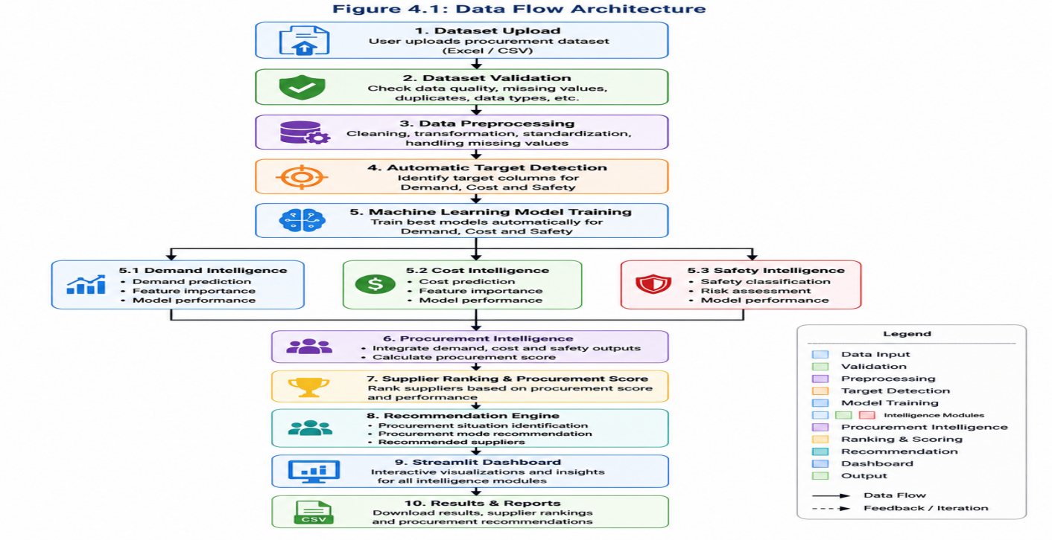

Figure 4.1: System Dataflow Diagram

The output of each intelligence module contributes to the final procurement recommendation process.

4.4 Intelligence Modules
The platform consists of four major intelligence modules:

Demand Intelligence Module
Analyzes procurement demand patterns and generates demand-related predictions. The module assists organizations in anticipating future procurement requirements.

Cost Intelligence Module
Evaluates procurement cost information and predicts future cost trends. The module supports cost optimization and budget planning activities.

Safety Intelligence Module
Assesses safety-related procurement factors and classifies procurement risks. The module supports safer supplier selection and compliance management.

Procurement Intelligence Module
Integrates outputs from the Demand, Cost, and Safety Intelligence modules to generate:
- Supplier Rankings
- Procurement Scores
- Procurement Situations
- Procurement Modes
- Supplier Recommendations
This module serves as the final decision-support layer of the platform.

4.5 Dashboard Architecture
The dashboard layer is developed using Streamlit and consists of the following components:
- Enterprise Overview
- Demand Intelligence Dashboard
- Cost Intelligence Dashboard
- Safety Intelligence Dashboard
- Procurement Intelligence Dashboard
- Model Performance Dashboard
- Dataset Intelligence Dashboard
These dashboards provide interactive visualizations and analytical insights for procurement decision-making.

4.6 Visualization Layer
The platform utilizes Plotly to generate interactive charts and analytics, including:
- Demand Prediction Charts
- Cost Prediction Charts
- Feature Importance Analysis
- Procurement Score Distribution
- Supplier Ranking Analysis
- Safety Risk Distribution
The visualization layer enhances the interpretability of machine learning outputs and procurement recommendations.

4.7 System Output
The final outputs generated by the platform include:
- Predicted Demand
- Predicted Cost
- Safety Assessment
- Procurement Scores
- Supplier Rankings
- Procurement Situations
- Procurement Modes
- Recommended Suppliers
These outputs assist procurement professionals in making informed and data-driven procurement decisions.

5. Project Structure

5.1 Overview
The Industrial Procurement Intelligence Platform follows a modular architecture where each module performs a specific function within the procurement intelligence workflow. This modular design improves maintainability, scalability, and ease of development.

5.2 Dashboard Module
The Dashboard Module provides the user interface of the application and is developed using Streamlit. It allows users to upload datasets, configure targets, execute intelligence modules, and visualize procurement insights.
Files:
- dashboard.py
- navigation.py
- theme.py
Responsibilities:
- User interaction
- Navigation management
- Dashboard styling
- Visualization display
- Result presentation

5.3 Data Processing Module
The Data Processing Module is responsible for preparing procurement datasets before machine learning model execution.
File:
- data_processor.py
Responsibilities:
- Dataset loading
- Target detection
- Entity detection
- Supplier detection
- Feature preparation
- Dataset transformation

5.4 Validation Module
The Validation Module performs quality assessment and integrity checks on uploaded datasets. This ensures that only valid and reliable data is used during analysis.
File Included:
- validation.py
Responsibilities:
- Missing value detection
- Duplicate record identification
- Dataset diagnostics
- Data quality assessment
- Validation reporting

5.5 Machine Learning Module
The Machine Learning Module forms the analytical core of the platform. It automatically selects appropriate algorithms, trains models, evaluates performance, and generates predictions for procurement intelligence.
File Included:
- model_engine.py
Responsibilities:
- Automated model selection
- Demand prediction
- Cost prediction
- Safety classification
- Model evaluation
- Performance scoring
- Feature importance generation

5.6 Visualization Module
The Visualization Module generates interactive charts and dashboards using Plotly. It converts analytical outputs into visual representations that support decision-making.
File Included:
- plotly_charts.py
Responsibilities:
- Demand analytics visualization
- Cost analytics visualization
- Feature importance charts
- Procurement score distribution
- Supplier ranking charts
- Safety risk visualization

5.7 Procurement Intelligence Module
The Procurement Intelligence Module integrates the outputs generated by the Demand, Cost, and Safety Intelligence models. It provides consolidated procurement recommendations and supplier evaluations.
Responsibilities:
- Procurement score calculation
- Supplier ranking
- Procurement situation identification
- Procurement mode recommendation
- Supplier recommendation generation
- Decision-support analytics

5.8 Module Interaction
The modules interact sequentially to perform procurement analysis. The uploaded dataset first undergoes validation and preprocessing. The processed data is then analyzed using machine learning models to generate demand, cost, and safety intelligence. These outputs are consolidated by the Procurement Intelligence Module and presented through the visualization and dashboard layers.
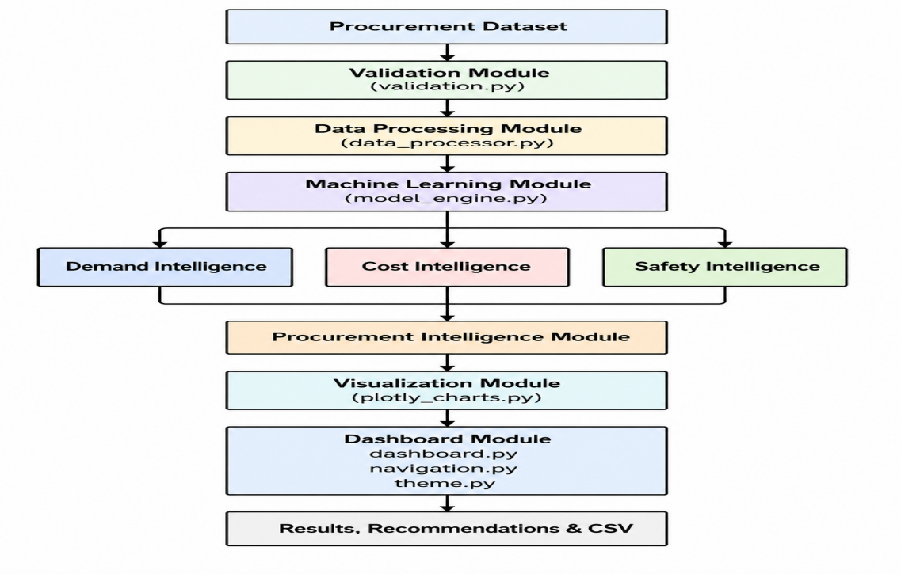
Figure 5.1: Interaction Between Major System Modules

5.9 Benefits of Modular Design
The modular architecture offers several advantages:
- Improved maintainability
- Easier debugging and testing
- Better scalability
- Reusable code components
- Simplified deployment
- Independent module enhancement
- Improved system organization
The modular structure enables efficient development and ensures that each component can be updated or extended without affecting the overall functionality of the platform.

6. Dataset Preparation

6.1 Supported File Formats
The Industrial Procurement Intelligence Platform accepts procurement datasets in Microsoft Excel format. The uploaded dataset serves as the primary input for all intelligence modules.
Supported Format:
- .xlsx (Microsoft Excel Workbook)
- .csv (Comma Separated Values(CSV))
Users should ensure that the dataset is properly structured and saved in the supported format before uploading it to the platform.

6.2 Dataset Requirements
The dataset should contain procurement-related information that enables the platform to perform demand prediction, cost prediction, safety classification, supplier evaluation, and procurement intelligence generation.
The dataset should:
- Contain procurement records from suppliers and components.
- Include numerical and categorical attributes.
- Have clearly defined target variables.
- Contain supplier-related information.
- Be free from excessive missing values.
- Maintain consistent data formatting.
For optimal performance, datasets should contain sufficient records to support machine learning model training and evaluation.

6.3 Mandatory Columns
The platform automatically detects procurement-related fields. However, the dataset should contain information representing the following categories:
Category | Purpose
Supplier Information | Supplier identification and ranking
Component Information | Product or part identification
Demand Information | Demand forecasting
Cost Information | Cost prediction
Safety Information | Safety classification
Production Information | In-house manufacturing analysis
Procurement Attributes | Procurement intelligence generation
Typical examples include:
- Supplier Name
- Part Name
- Demand Quantity
- Procurement Cost
- Safety Score
- In-House Capacity
- In-House Cost
- Production Requirement

6.4 Recommended Dataset Structure
A recommended procurement dataset structure is shown below:
Supplier | Part Name | Demand | Cost | Safety Score | In-House Capacity | In-House Cost
ABB | Servo Motor | 500 | 1200 | 92 | 450 | 1100
Siemens | PLC Unit | 300 | 1500 | 88 | 350 | 1400
Schneider | Sensor Module | 700 | 950 | 95 | 600 | 900
This structure enables the platform to automatically identify relevant procurement intelligence targets.

6.5 Sample Dataset
The project was tested using a procurement dataset containing:
Dataset Attribute | Value
Total Records | 10,000
Total Columns | 24
Features | 17
Target Variables | 6
Missing Values | 0
The dataset included supplier information, demand data, procurement cost details, safety indicators, and manufacturing capability information.
The prepared dataset is subsequently passed to the validation and preprocessing stage, where quality checks and diagnostics are performed before machine learning analysis begins.
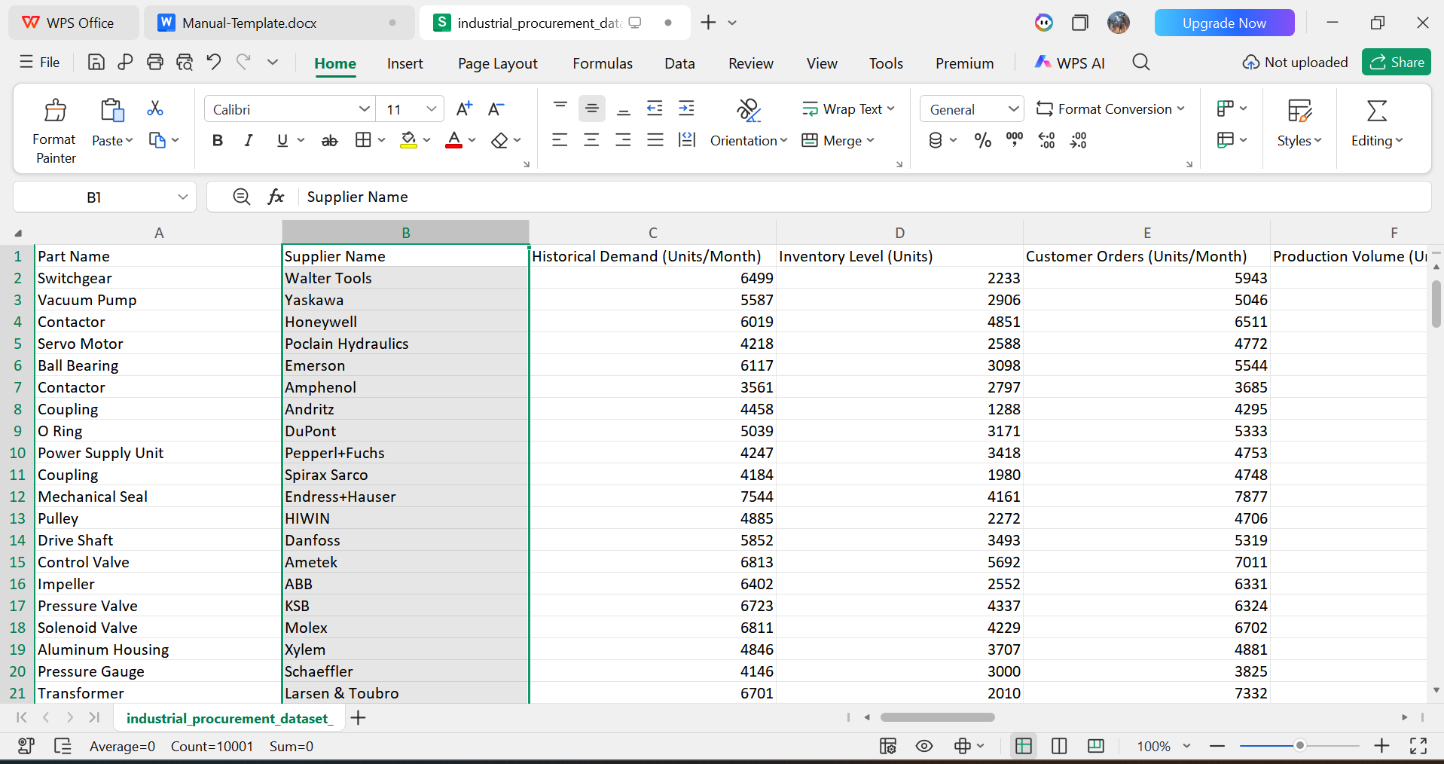
Figure 6.1: Sample Procurement Dataset Structure

7. Data Validation and Preprocessing

7.1 Dataset Validation
Before performing any machine learning analysis, the platform automatically validates the uploaded procurement dataset to ensure data quality and consistency.
The validation process checks:
- Dataset dimensions
- Column availability
- Data completeness
- Data type consistency
- Supplier information availability
- Target variable availability
Only datasets that successfully pass the validation stage proceed to further analysis.

7.2 Missing Value Handling
Missing values can negatively affect machine learning performance and procurement recommendations. The platform automatically identifies missing entries within the dataset and generates preprocessing diagnostics.
The missing value analysis helps users:
- Identify incomplete records
- Assess dataset quality
- Determine data readiness
- Improve prediction reliability
Datasets with minimal or no missing values provide the best analytical performance.

7.3 Duplicate Detection
Duplicate procurement records can distort model training and influence supplier evaluation results. Therefore, the platform performs duplicate record detection during preprocessing.
The duplicate detection process:
- Identifies repeated procurement records
- Calculates duplicate counts
- Supports data quality assessment
- Prevents redundant model training observations
This step improves the overall reliability of procurement intelligence generation.

7.4 Data Cleaning
The platform performs basic data cleaning operations to prepare the dataset for machine learning analysis.
The cleaning process includes:
- Removal of invalid records
- Standardization of column names
- Formatting consistency checks
- Verification of numerical fields
- Verification of categorical fields
These operations ensure that the dataset is suitable for automated processing.

7.5 Dataset Diagnostics
After validation and preprocessing, the platform generates a dataset diagnostic summary.
The diagnostic report provides:
Diagnostic Metric | Description
Total Records | Number of observations in the dataset
Total Columns | Number of available attributes
Feature Count | Number of input features
Target Count | Number of detected target variables
Missing Values | Number of null values identified
Duplicate Records | Number of repeated observations
The diagnostics report provides users with a comprehensive overview of dataset quality before model training begins.

7.6 Preprocessing Output
Upon successful completion of validation and preprocessing, the dataset becomes ready for automated target detection and machine learning analysis.
The preprocessing stage outputs:
- Cleaned dataset
- Validation report
- Missing value summary
- Duplicate record summary
- Dataset diagnostics report
These outputs form the foundation for subsequent intelligence modules.
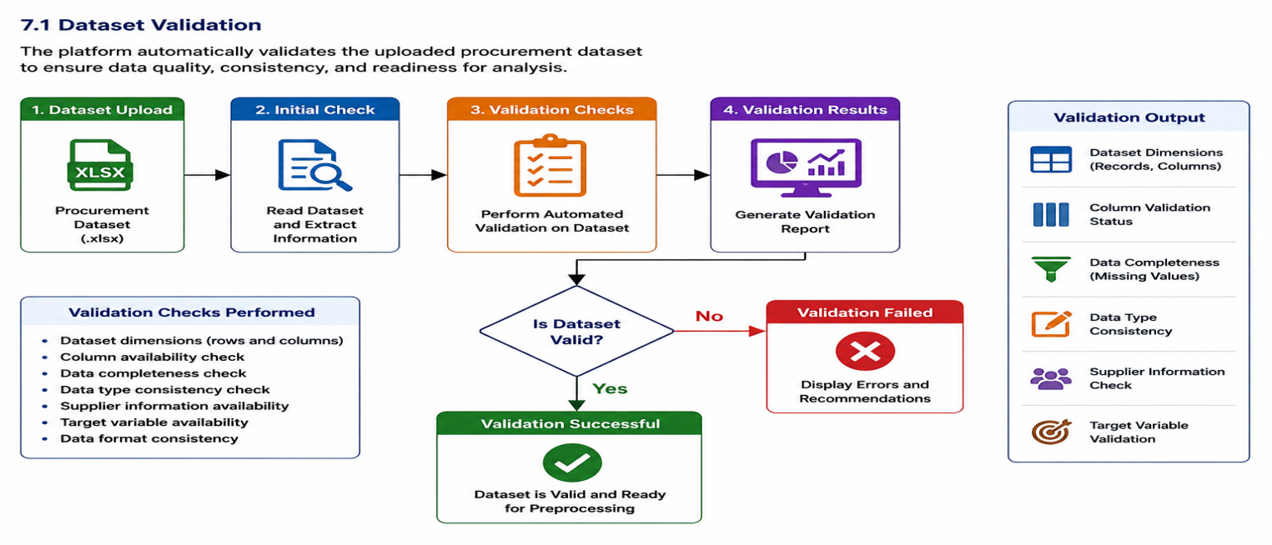
Figure 7.1: Dataset Validation and Preprocessing Workflow

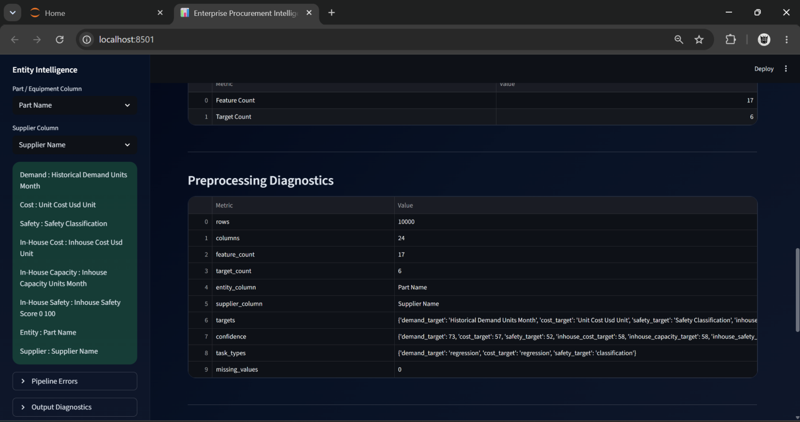
Figure 7.2: Dataset Diagnostics Dashboard

8. Automated Target Detection

8.1 Overview
The Industrial Procurement Intelligence Platform incorporates an Automated Target Detection Engine that identifies target variables directly from the uploaded procurement dataset. This eliminates the need for manual configuration and allows the platform to adapt to datasets with varying naming conventions.
The target detection mechanism analyzes column names, metadata, and procurement-related keywords to identify the most suitable target variables for Demand Intelligence, Cost Intelligence, Safety Intelligence, and Procurement Intelligence analysis.

8.2 Demand Target Detection
The Demand Target Detection Engine identifies columns related to procurement demand, production requirements, customer orders, and inventory consumption.
Common demand-related columns include:
- Demand Quantity
- Customer Demand
- Production Requirement
- Monthly Demand
- Forecast Demand
- Order Quantity
Once identified, the selected target is used for demand prediction model training.

8.3 Cost Target Detection
The Cost Target Detection Engine identifies procurement cost-related variables from the dataset.
Typical cost-related columns include:
- Procurement Cost
- Unit Cost
- Material Cost
- Manufacturing Cost
- Purchase Cost
- Supplier Cost
The detected target is subsequently used for cost prediction and optimization analysis.

8.4 Safety Target Detection
The Safety Target Detection Engine identifies safety-related attributes associated with suppliers, components, or procurement activities.
Examples include:
- Safety Score
- Risk Rating
- Safety Classification
- Compliance Rating
- Supplier Safety Index
The selected safety target is used for classification model development and risk evaluation.

8.5 In-House Cost Detection
The platform automatically detects columns associated with internal manufacturing costs.
Typical examples include:
- In-House Cost
- Manufacturing Cost
- Internal Production Cost
- Production Expense
These values are used during procurement mode recommendation and make-versus-buy analysis.

8.6 In-House Capacity Detection
The platform identifies manufacturing capacity-related columns that indicate the organization's production capability.
Examples include:
- Production Capacity
- Manufacturing Capacity
- Available Capacity
- Internal Capacity
This information is used to determine whether demand can be fulfilled internally or requires supplier support.

8.7 In-House Safety Detection
Safety-related manufacturing variables are also identified to support safe internal production planning.
Examples include:
- Internal Safety Score
- Production Safety Rating
- Manufacturing Risk Index
These variables contribute to procurement mode evaluation and operational decision-making.

8.8 Automated Detection Workflow
The automated detection process follows the sequence below:
- Dataset Upload
- Column Name Analysis
- Keyword Matching
- Target Candidate Identification
- Target Validation
- Target Assignment
- Model Configuration
This process ensures consistent target identification across different procurement datasets.

8.9 Detection Output
The Target Detection Engine generates:
- Demand Target
- Cost Target
- Safety Target
- In-House Cost Target
- In-House Capacity Target
- In-House Safety Target
These outputs are automatically passed to the machine learning framework for model development.
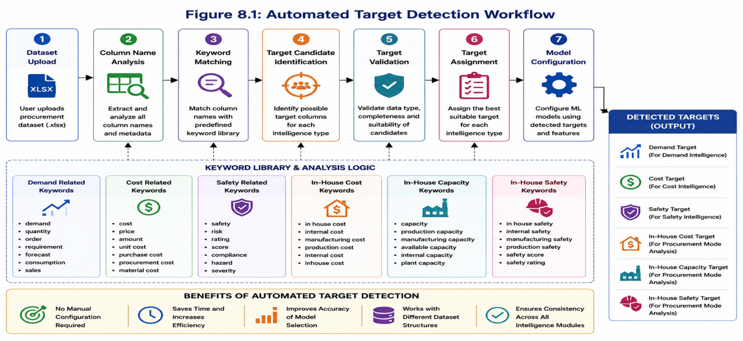

Figure 8.1:Automated Target Detection Workflow

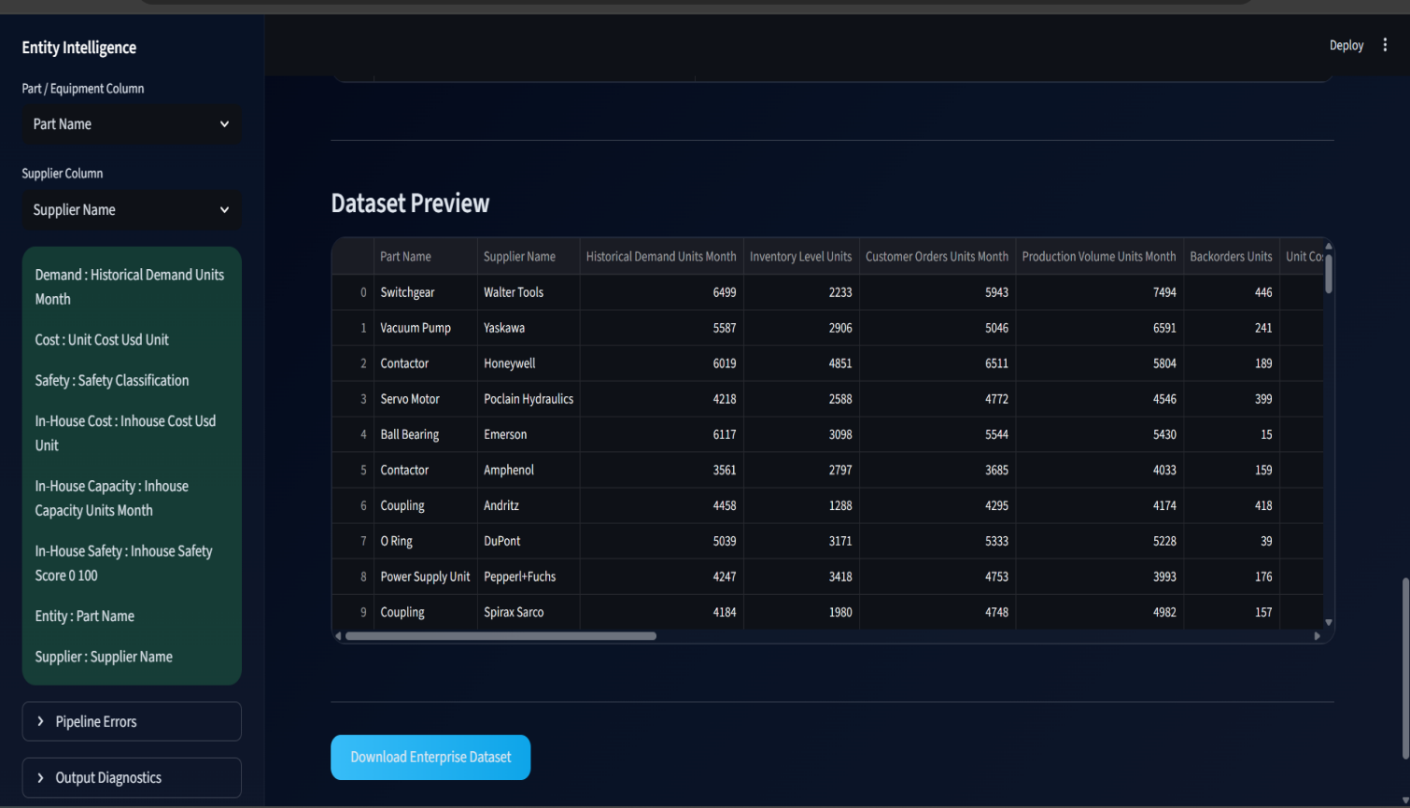

Figure 8.2: Detected Targets Display Dashboard

9. Machine Learning Framework

9.1 Automated Model Selection
The Industrial Procurement Intelligence Platform utilizes an Automated Model Selection Framework to identify the most suitable machine learning algorithm for each intelligence module.
The framework evaluates multiple algorithms and selects the model that achieves the highest performance score on the provided dataset.
This approach eliminates manual model selection and improves predictive performance.

9.2 Regression Models
Regression algorithms are used for numerical prediction tasks such as Demand Intelligence and Cost Intelligence.
Candidate regression models include:
- Random Forest Regressor
- Extra Trees Regressor
- Gradient Boosting Regressor
- XGBoost Regressor
- Linear Regression
The platform automatically evaluates these models and selects the best-performing algorithm.

9.3 Classification Models
Classification algorithms are used for Safety Intelligence and risk assessment tasks.
Candidate classification models include:
- Random Forest Classifier
- Extra Trees Classifier
- Gradient Boosting Classifier
- XGBoost Classifier
- Logistic Regression
The selected classifier is used to generate safety classifications and risk predictions.

9.4 Model Training Process
The machine learning workflow consists of:
- Dataset Preparation
- Target Detection
- Feature Selection
- Train-Test Split
- Model Training
- Model Evaluation
- Performance Comparison
- Best Model Selection
This process is repeated independently for Demand, Cost, and Safety Intelligence pipelines.

9.5 Performance Evaluation
The AI-Powered Enterprise Procurement Intelligence Platform employs a comprehensive performance evaluation framework to assess the effectiveness, reliability, and predictive capability of machine learning models. During model training, multiple candidate algorithms are evaluated and compared using standardized performance metrics. The model demonstrating the best overall performance is automatically selected for intelligence generation and procurement decision support.
Performance evaluation is performed separately for regression-based prediction tasks and classification-based prediction tasks.

Regression Performance Metrics
Regression metrics are used when the target variable contains continuous numerical values, such as demand quantities, procurement costs, inventory levels, or production requirements.
R² Score (Coefficient of Determination)
R² Score measures the proportion of variation in the target variable that can be explained by the machine learning model. It indicates how effectively the model captures relationships between input features and prediction outcomes. Higher R² values indicate better predictive performance and stronger model accuracy.
Mean Absolute Error (MAE)
Mean Absolute Error measures the average absolute difference between actual values and predicted values. It provides a direct indication of prediction accuracy by quantifying the average prediction error. Lower MAE values indicate that predictions are closer to actual observations.
Root Mean Square Error (RMSE)
Root Mean Square Error measures the magnitude of prediction errors while assigning greater importance to larger deviations. RMSE is particularly useful for identifying models that occasionally generate significant prediction errors. Lower RMSE values indicate improved prediction consistency and reliability.
Mean Absolute Percentage Error (MAPE)
Mean Absolute Percentage Error expresses prediction error as a percentage of actual values. This metric provides a business-oriented interpretation of prediction accuracy and enables easy comparison across different datasets. Lower MAPE values indicate higher prediction accuracy.

Classification Performance Metrics
Classification metrics are used when the target variable contains categorical classes such as safety classifications, supplier categories, procurement modes, or risk levels.
Accuracy
Accuracy represents the percentage of observations correctly classified by the machine learning model. It provides an overall measure of classification performance and prediction correctness. Higher accuracy values indicate superior classification capability.
Precision
Precision measures the proportion of positive classifications that are actually correct. It evaluates the reliability of positive predictions generated by the model. Higher precision values indicate fewer false positive classifications.
Recall
Recall measures the ability of the model to identify all relevant positive observations within the dataset. It evaluates how effectively the model captures actual positive cases. Higher recall values indicate stronger detection capability and reduced false negative classifications.
F1-Score
F1-Score combines Precision and Recall into a single performance measure. It provides a balanced assessment of classification effectiveness and is particularly useful when class distributions are uneven. Higher F1-Score values indicate improved overall classification performance.

Automated Model Selection
The platform automatically evaluates multiple machine learning algorithms using the above performance metrics. Each candidate model is trained and validated using the processed dataset, and the model achieving the best performance is selected for deployment within the corresponding Demand Intelligence, Cost Intelligence, Safety Intelligence, or Procurement Intelligence pipeline.
This evaluation framework ensures that the platform consistently utilizes the most accurate and reliable machine learning models for enterprise procurement decision support.

9.6 Feature Importance Analysis
Feature importance analysis identifies the most influential procurement variables contributing to prediction accuracy.
The analysis helps users:
- Understand key procurement drivers
- Improve decision-making
- Interpret machine learning outputs
- Identify critical supplier factors
Feature importance results are visualized through interactive dashboards.

9.7 Model Selection Results
During experimental evaluation, the following models were automatically selected:
Intelligence Pipeline | Selected Model
Demand Intelligence | XGBoost
Cost Intelligence | Extra Trees
Safety Intelligence | Random Forest
These models achieved the highest performance scores on the procurement dataset.
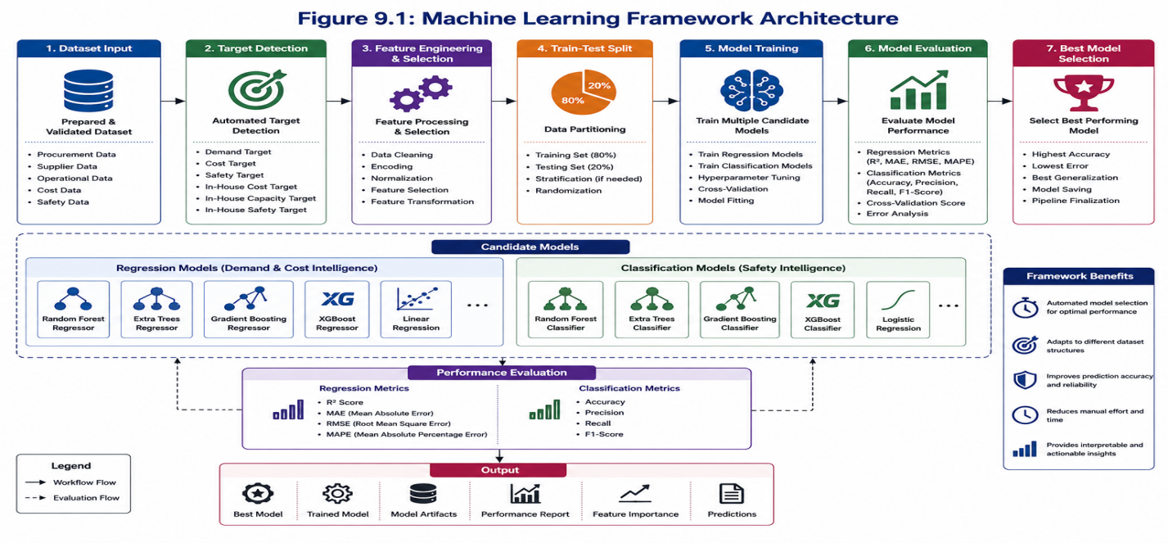

Figure 9.1: Machine Learning Framework Architecture

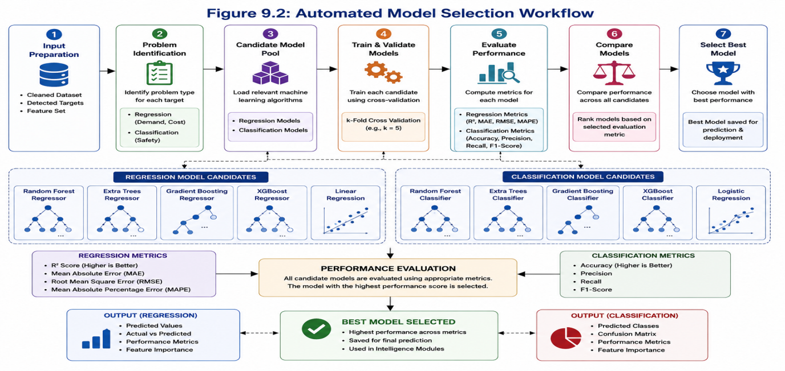
Figure 9.2: Automated Model Selection Workflow
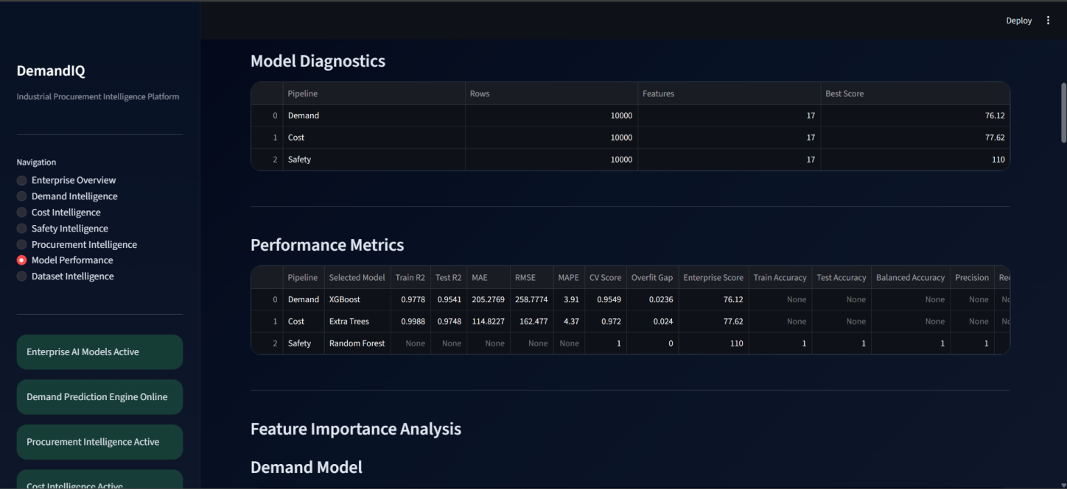

Figure 9.3: Model Performance Dashboard

10. Demand Intelligence Module

10.1 Module Overview
The Demand Intelligence Module predicts future procurement demand using historical procurement and operational data. It assists organizations in forecasting component requirements and planning procurement activities proactively.
The module supports demand-driven procurement planning and inventory optimization.

10.2 Input Parameters
The Demand Intelligence Module utilizes procurement-related variables such as:
- Customer Orders
- Production Requirements
- Inventory Levels
- Supplier Performance
- Procurement History
- Operational Indicators
These variables serve as input features for machine learning-based demand prediction.

10.3 Demand Prediction Workflow
The workflow consists of:
- Demand Target Detection
- Dataset Preparation
- Model Selection
- Model Training
- Demand Prediction
- Performance Evaluation
- Dashboard Visualization
The resulting model generates predicted demand values for procurement planning.

10.4 Generated Outputs
The module generates:
- Predicted Demand
- Demand Score
- Feature Importance Rankings
- Demand Analytics
- Demand Forecast Visualizations
These outputs support procurement planning and supplier management activities.

10.5 Performance Metrics
The Demand Intelligence model is evaluated using:
- R² Score
- MAE
- RMSE
- MAPE
These metrics measure prediction accuracy and model reliability.

10.6 Interpretation of Results
Higher prediction accuracy indicates stronger forecasting capability and improved procurement planning reliability.
Users can utilize the generated demand forecasts to:
- Anticipate procurement requirements
- Optimize inventory levels
- Reduce stock shortages
- Improve production planning
- Support supplier negotiations

10.7 Demand Intelligence Dashboard
The Demand Intelligence Dashboard provides:
- Predicted Demand Values
- Actual vs Predicted Comparison
- Feature Importance Analysis
- Model Performance Metrics
- Demand Trend Visualizations
These visualizations enable users to understand procurement demand behavior and make informed decisions.
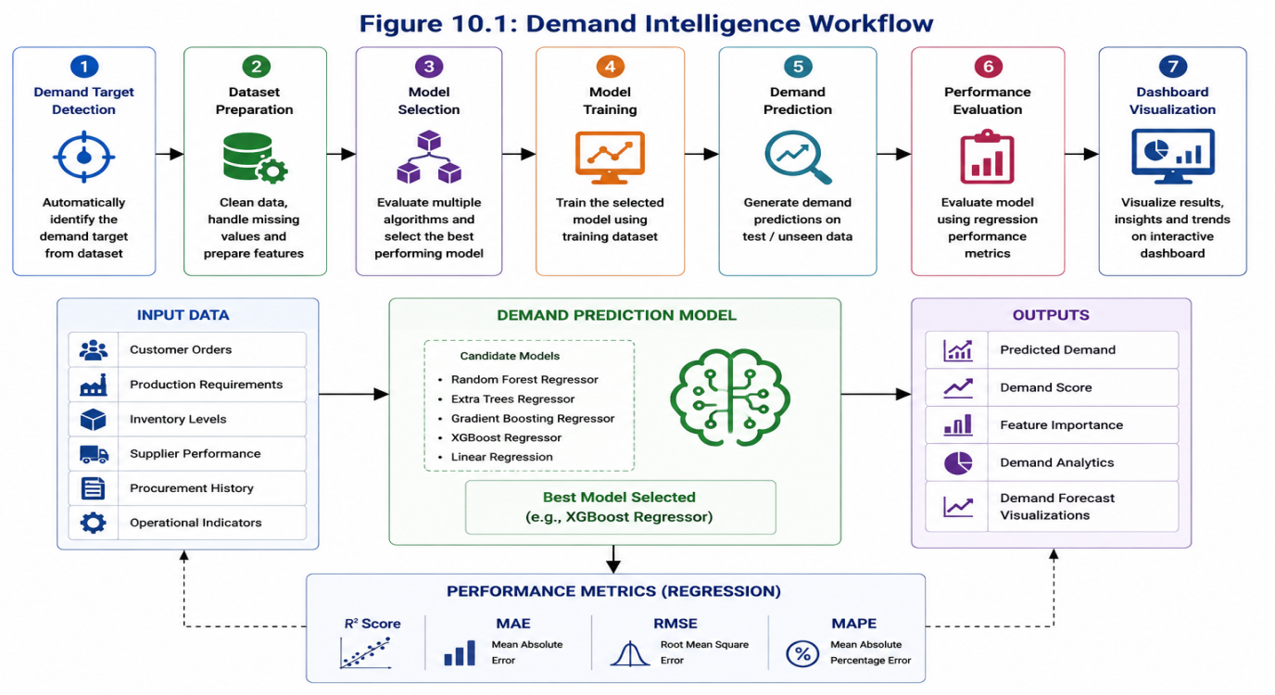
Figure 10.1: Demand Intelligence Workflow
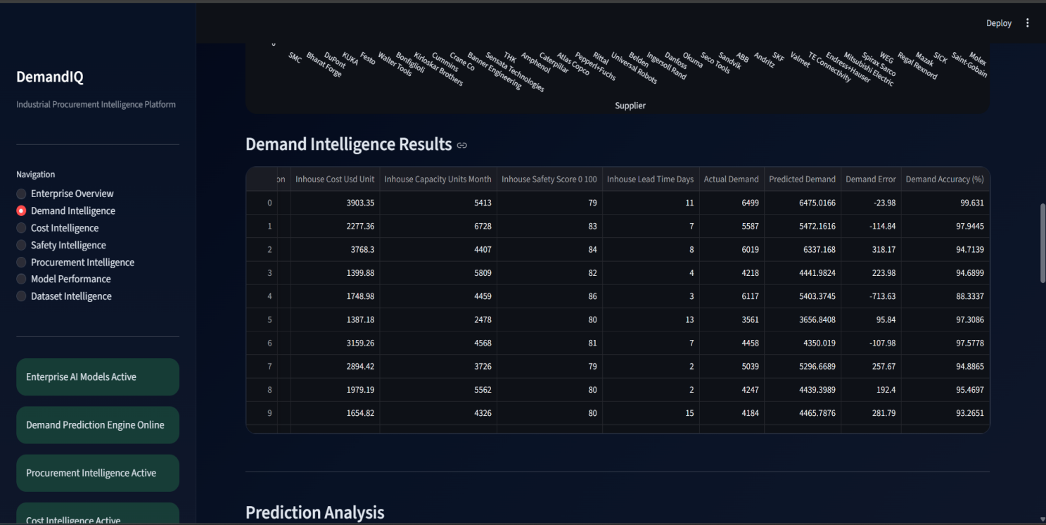
Figure 10.2: Demand Prediction Dashboard
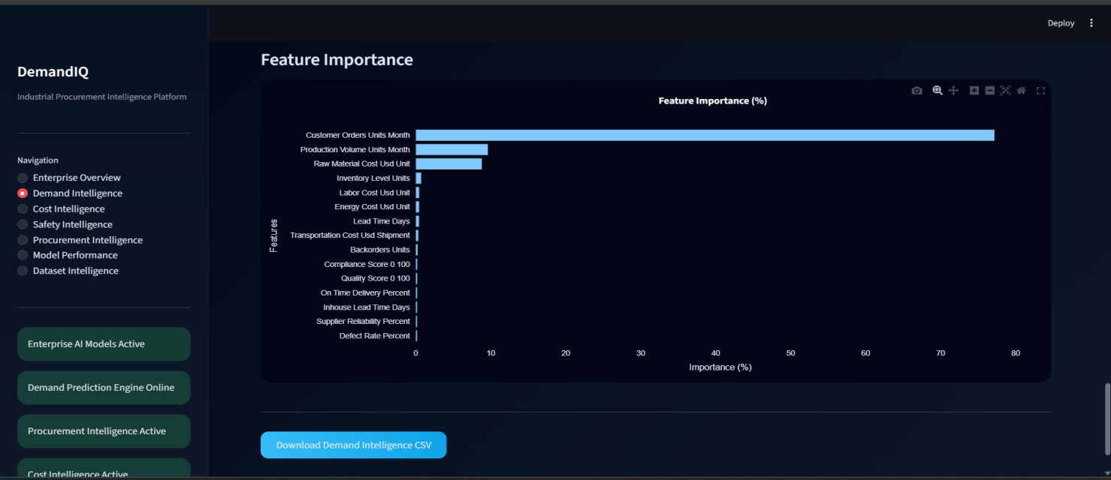
Figure 10.3: Feature Importance Analysis
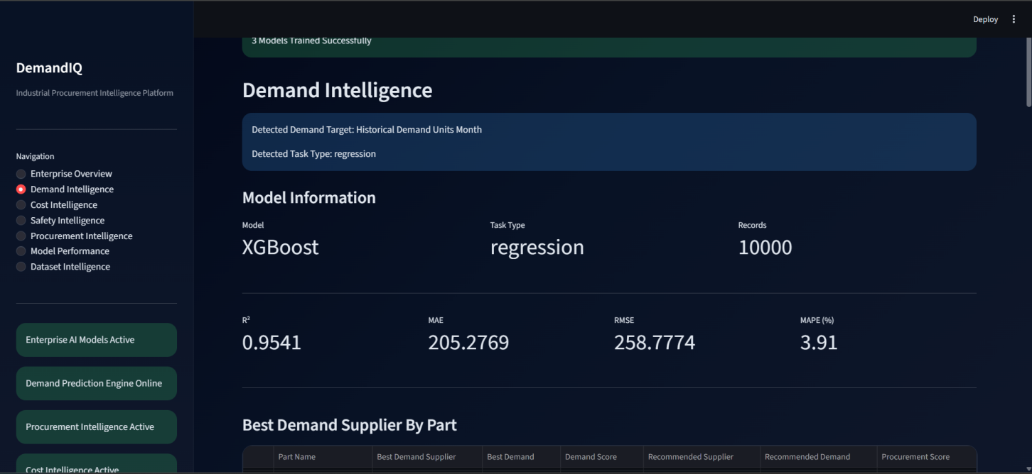
Figure 10.4: Demand Model Performance Metrics Dashboard

11. Cost Intelligence Module

11.1 Module Overview
The Cost Intelligence Module predicts procurement costs using machine learning algorithms trained on historical procurement and supplier data. The module enables organizations to estimate future procurement expenses, identify cost drivers, and support cost-efficient purchasing decisions.
The module assists procurement managers in controlling procurement expenditure and improving budget planning.

11.2 Input Parameters
The Cost Intelligence Module utilizes procurement-related attributes such as:
- Raw Material Cost
- Labor Cost
- Transportation Cost
- Supplier Cost
- Inventory Cost
- Operational Cost
- Production Cost
- Procurement History
These parameters are used as input features for cost prediction models.

11.3 Cost Prediction Workflow
The workflow consists of:
- Cost Target Detection
- Dataset Preparation
- Model Selection
- Model Training
- Cost Prediction
- Performance Evaluation
- Dashboard Visualization
The selected machine learning model generates procurement cost estimates for future procurement activities.

11.4 Generated Outputs
The module generates:
- Predicted Cost
- Cost Score
- Cost Analytics
- Feature Importance Rankings
- Cost Forecast Visualizations
These outputs support procurement budgeting and supplier negotiations.

11.5 Performance Metrics
The Cost Intelligence Module is evaluated using:
- R² Score
- Mean Absolute Error (MAE)
- Root Mean Square Error (RMSE)
- Mean Absolute Percentage Error (MAPE)
These metrics assess the accuracy and reliability of procurement cost predictions.

11.6 Interpretation of Results
The generated cost predictions help procurement teams:
- Estimate future procurement expenses
- Identify major cost drivers
- Optimize supplier selection
- Reduce procurement risks
- Improve budget allocation
Higher model accuracy indicates more reliable procurement cost forecasting.
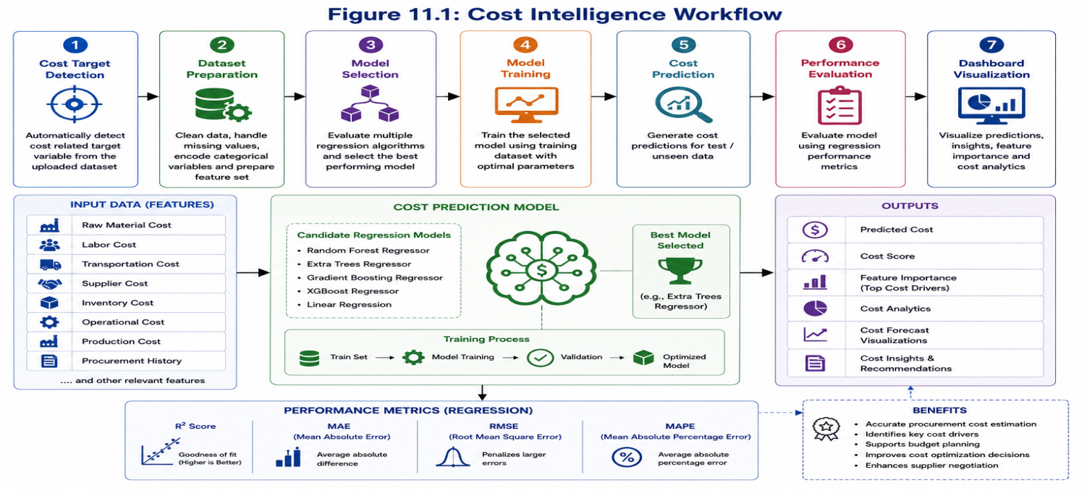
Figure 11.1: Cost Intelligence Dashboard
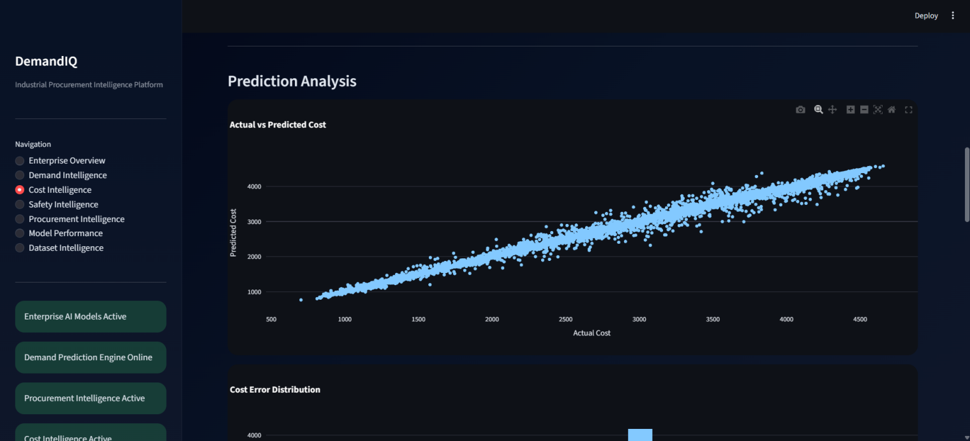
Figure 11.2: Cost Intelligence Dashboard
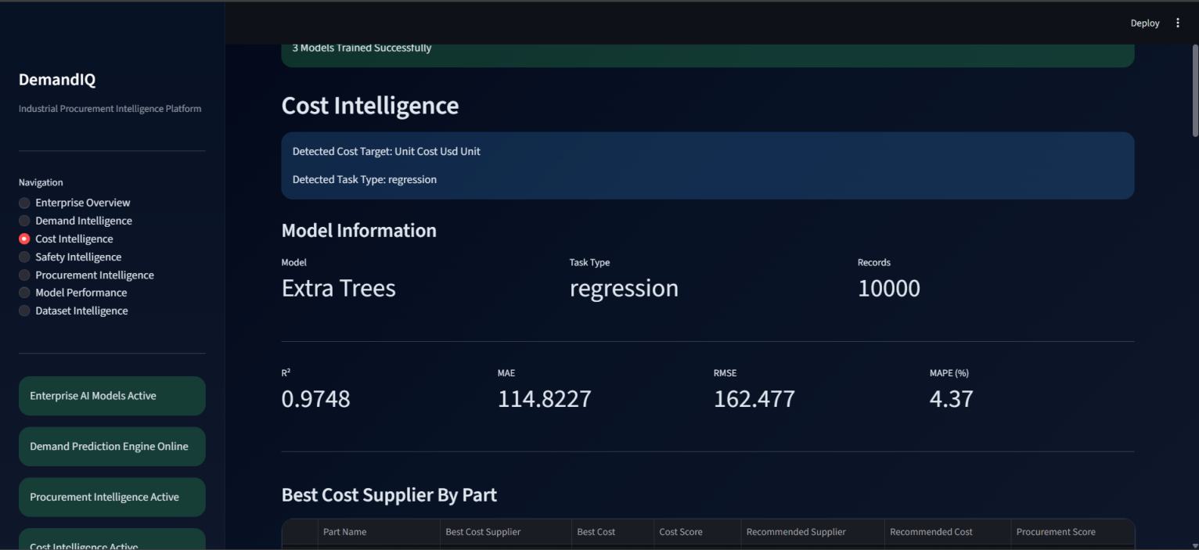
Figure 11.3: Cost Model Performance Metrics Dashboard

12. Safety Intelligence Module

12.1 Module Overview
The Safety Intelligence Module evaluates supplier safety performance and procurement risk using machine learning classification techniques. The module helps organizations identify safer suppliers and improve procurement compliance.

12.2 Input Parameters
The Safety Intelligence Module utilizes:
- Safety Score
- Risk Rating
- Compliance Rating
- Supplier Reliability
- Quality Indicators
- Operational Safety Metrics
These variables are used to train classification models and assess supplier safety performance.

12.3 Safety Classification Workflow
The workflow consists of:
- Safety Target Detection
- Dataset Preparation
- Classification Model Selection
- Model Training
- Safety Classification
- Performance Evaluation
- Dashboard Visualization
The selected model predicts safety levels and identifies procurement risks.

12.4 Generated Outputs
The module generates:
- Predicted Safety Score
- Safety Classification
- Risk Category
- Supplier Safety Rankings
- Safety Analytics
These outputs support supplier evaluation and risk management.

12.5 Safety Risk Interpretation
Safety classifications are interpreted as:
Safety Score Range | Risk Level
80 – 100 | Low Risk
60 – 79 | Medium Risk
Below 60 | High Risk

Higher safety scores indicate safer procurement conditions and more reliable suppliers.
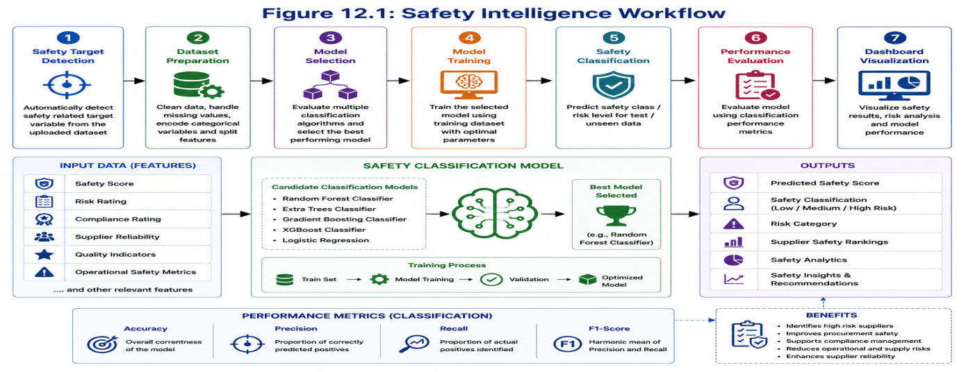
Figure 12.1: Safety Intelligence Workflow

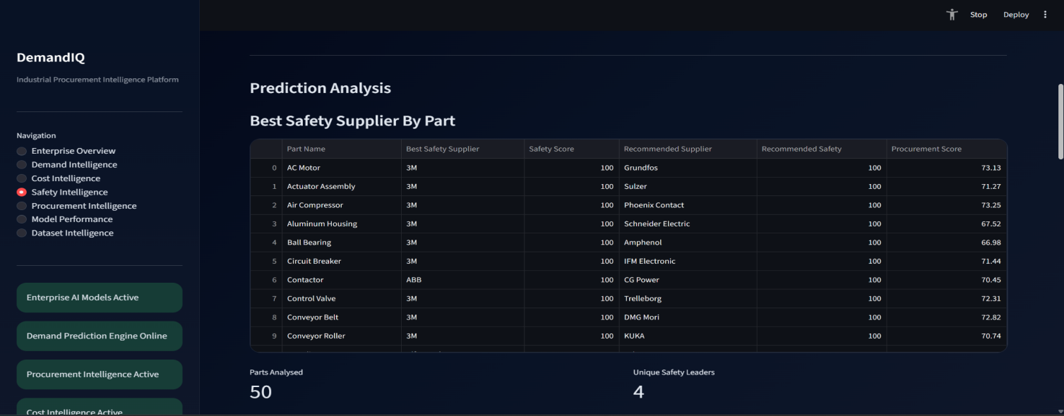

Figure 12.2: Safety Intelligence Dashboard

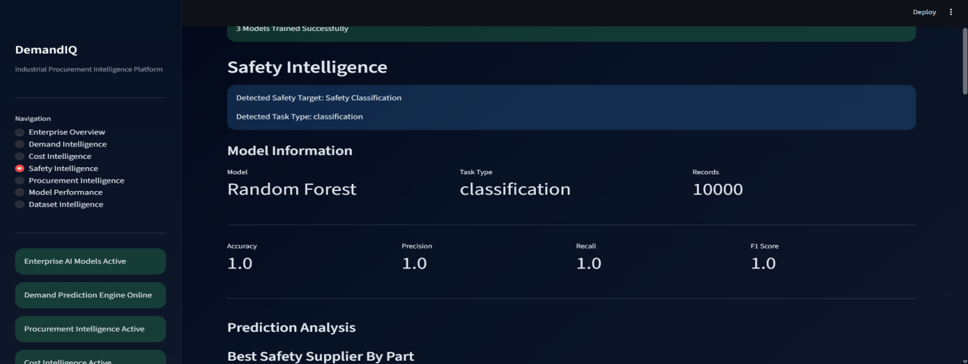

Figure 12.3: Safety Model Performance Metrics Dashboard

13. Procurement Intelligence Module

13.1 Procurement Intelligence Overview
The Procurement Intelligence Module integrates outputs from Demand Intelligence, Cost Intelligence, and Safety Intelligence to generate optimized procurement recommendations. It serves as the final decision-support layer of the platform.

13.2 Supplier Competition Analysis
The platform evaluates suppliers based on:
- Demand Fulfillment Capability
- Procurement Cost Efficiency
- Safety Performance
- Manufacturing Capability
Each supplier is assessed across multiple procurement dimensions.

13.3 Procurement Score Calculation
The Procurement Score combines:
- Demand Score
- Cost Score
- Safety Score
The resulting score represents overall supplier competitiveness and procurement suitability.

13.4 Procurement Situation Analysis
The platform categorizes procurement decisions into:

Balanced Procurement
Demand, cost, and safety are balanced.

High Demand / High Cost Risk
Demand requirements are high while procurement costs remain elevated.

Cost Efficient Procurement
Low procurement costs with acceptable demand and safety performance.

13.5 Procurement Mode Recommendation
The system recommends:

In-House Manufacturing
Demand can be fulfilled internally.

External Supplier Procurement
Procurement should be performed through suppliers.

Hybrid Procurement
Demand should be fulfilled using both internal production and suppliers.

13.6 Supplier Recommendation Engine
The recommendation engine identifies:
- Best Demand Supplier
- Best Cost Supplier
- Best Safety Supplier
- Recommended Supplier
The final recommendation is based on consolidated procurement intelligence.

13.7 Procurement Intelligence Dashboard
The dashboard displays:
- Procurement Scores
- Supplier Rankings
- Procurement Situations
- Procurement Modes
- Recommended Suppliers
- Procurement Analytics
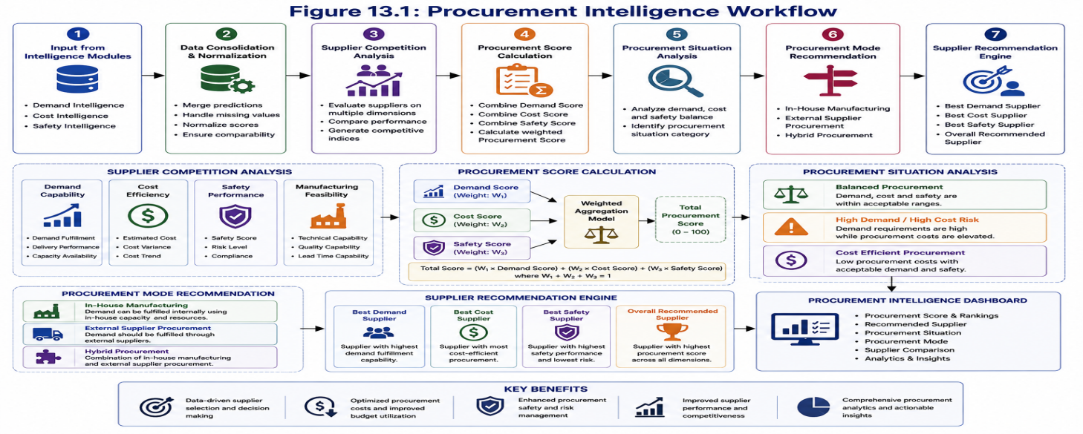

Figure 13.1:Procurement Intelligence Workflow

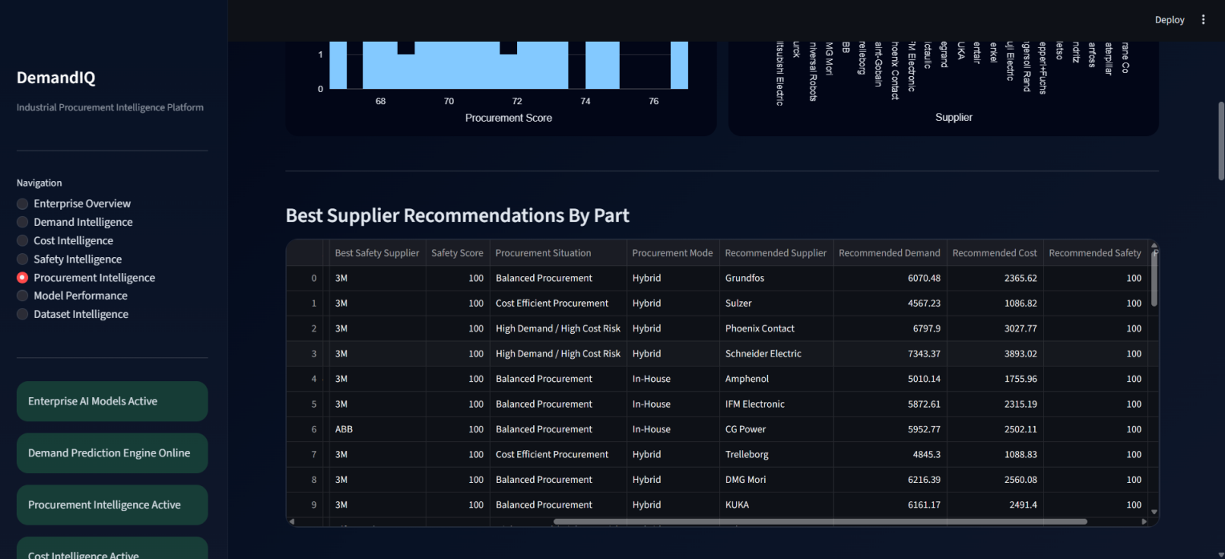

Figure 13.2: Procurement Intelligence Dashboard

14. Dashboard User Guide

14.1 Launching the Application
The Industrial Procurement Intelligence Platform is deployed as a Streamlit web application. Users can launch the application using the command line interface.
Open Anaconda Prompt and navigate to the project directory:
cd Industrial_Procurement_Intelligence_Platform
Run the Streamlit application:
streamlit run dashboard/dashboard.py
Upon successful execution, the application launches in the default web browser at:
http://localhost:8501
The Enterprise Overview page is displayed as the default landing page.

14.2 Uploading Datasets
To begin analysis, users must upload a procurement dataset.
Steps:
- Open the dashboard.
- Navigate to the dataset upload section.
- Click Browse Files.
- Select the procurement dataset (.xlsx).
- Upload the file.
- Wait for validation and preprocessing to complete.
Once uploaded, the platform automatically begins dataset inspection and diagnostics.
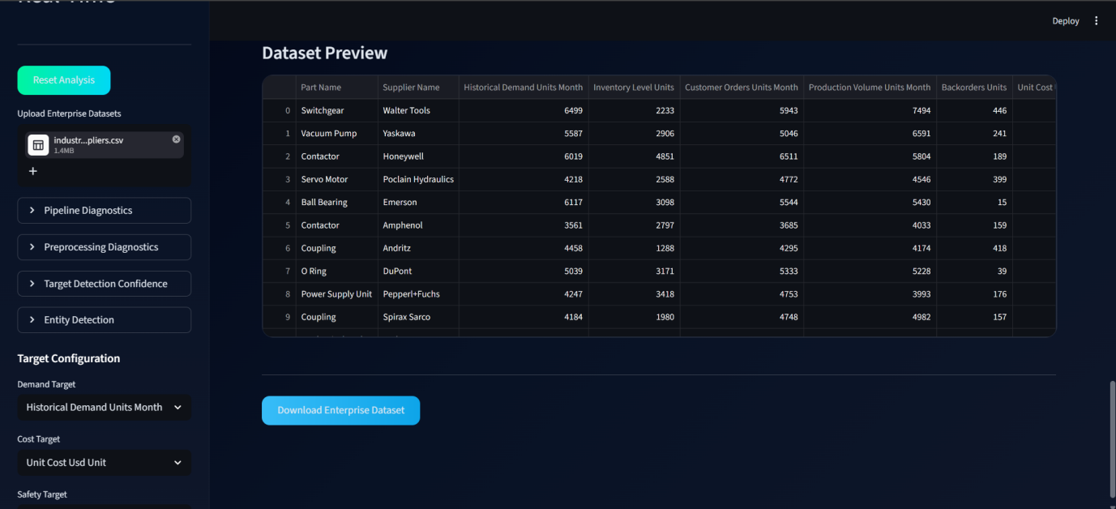
Figure 14.1: Dataset Upload Interface

14.3 Automatic Target Detection
After dataset upload, the platform automatically identifies relevant target variables required for intelligence generation.
Detected targets include:
- Demand Target
- Cost Target
- Safety Target
- In-House Cost Target
- In-House Capacity Target
- In-House Safety Target
The detected targets are displayed within the dashboard and are automatically configured for model training.

14.4 Manual Target Configuration
If the automatically detected target is incorrect or multiple candidate columns exist, users may manually configure the target variables.
Manual configuration allows:
- Alternative target selection
- Custom analysis setup
- Greater control over model training
The selected targets are then used by the machine learning framework.
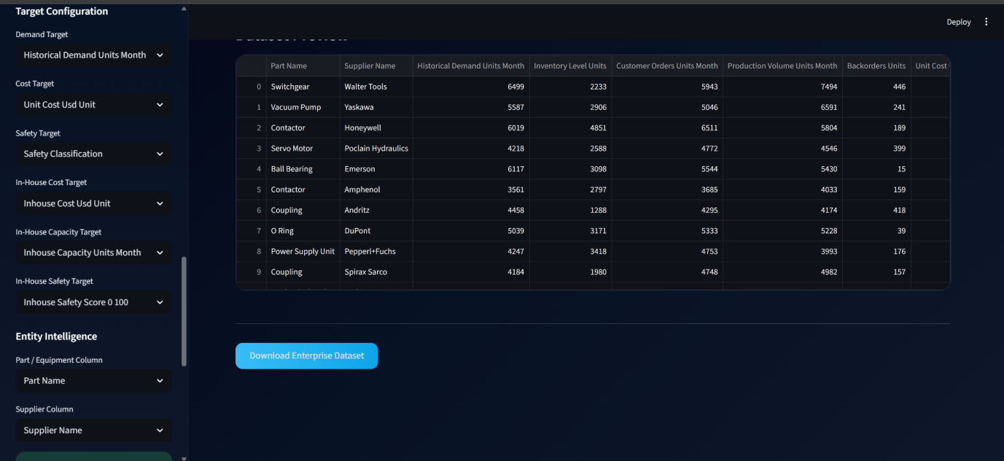
Figure 14.2: Manual Target Configuration Interface

14.5 Running Procurement Analysis
After target detection and validation, users can execute procurement intelligence analysis.
Steps:
- Select the desired dashboard module.
- Initiate model training.
- Allow model evaluation to complete.
- Review generated predictions.
- Analyze procurement recommendations.
The platform automatically performs:
- Demand Intelligence
- Cost Intelligence
- Safety Intelligence
- Procurement Intelligence
without requiring additional configuration.

14.6 Viewing Results
The generated results are displayed through interactive dashboards.
Available outputs include:
- Demand Predictions
- Cost Predictions
- Safety Assessments
- Procurement Scores
- Supplier Rankings
- Recommended Suppliers
- Procurement Modes
- Procurement Situations
These results support data-driven procurement decision-making.

15. Dashboard Pages

15.1 Enterprise Overview Page
The Enterprise Overview page provides a high-level summary of platform activity and procurement intelligence results.
Information displayed includes:
- Dataset Statistics
- Number of Features
- Number of Targets
- Models Trained
- Enterprise Status Indicators
- Intelligence Module Status
This page acts as the primary monitoring dashboard for the platform.
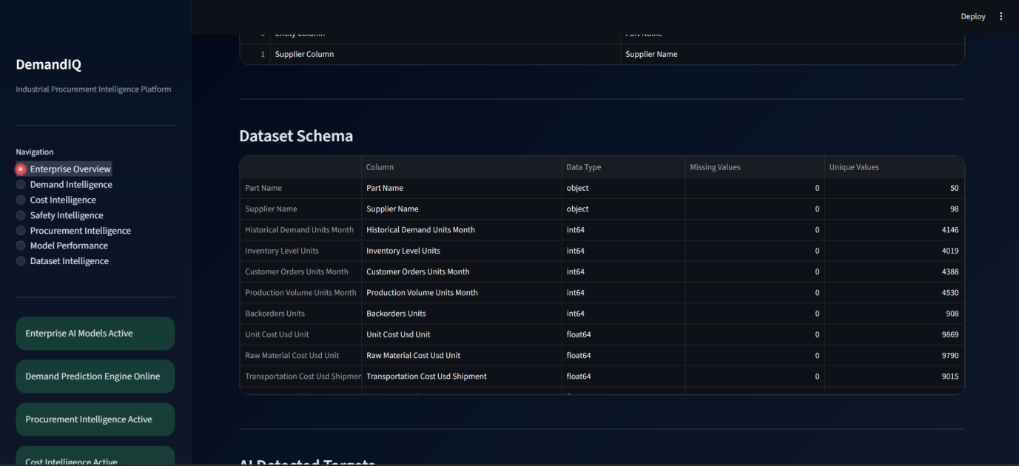
Figure 15.1: Enterprise Overview Dashboard

15.2 Demand Intelligence Page
The Demand Intelligence page provides procurement demand forecasting insights.
Displayed information includes:
- Predicted Demand Values
- Demand Analytics
- Demand Forecast Charts
- Feature Importance Analysis
- Demand Model Performance Metrics
This page assists procurement planning and inventory management.
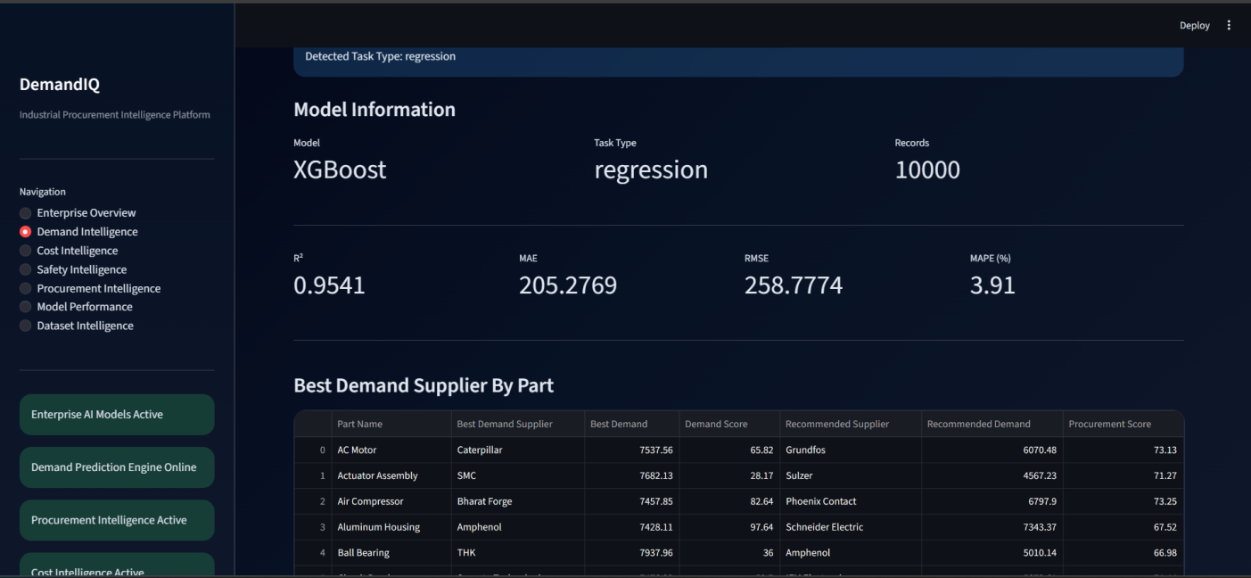
Figure 15.2: Demand Intelligence Dashboard

15.3 Cost Intelligence Page
The Cost Intelligence page focuses on procurement cost prediction and optimization.
Displayed information includes:
- Predicted Procurement Cost
- Cost Analytics
- Cost Forecast Charts
- Cost Feature Importance
- Cost Model Performance Metrics
This page supports budgeting and cost-control activities.
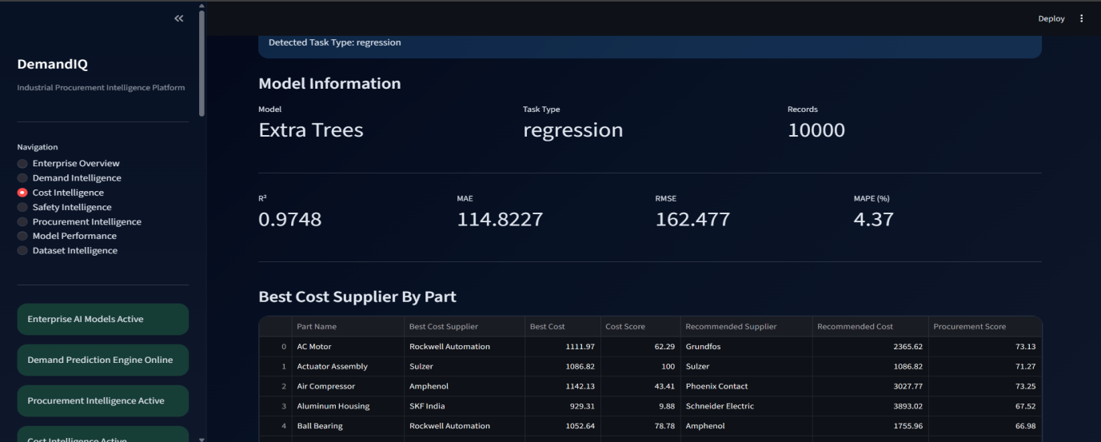
Figure 15.3: Cost Intelligence Dashboard

15.4 Safety Intelligence Page
The Safety Intelligence page provides supplier risk assessment and safety classification results.
Displayed information includes:
- Predicted Safety Scores
- Risk Categories
- Safety Analytics
- Supplier Safety Rankings
- Classification Performance Metrics
This page assists procurement risk management and supplier compliance evaluation.
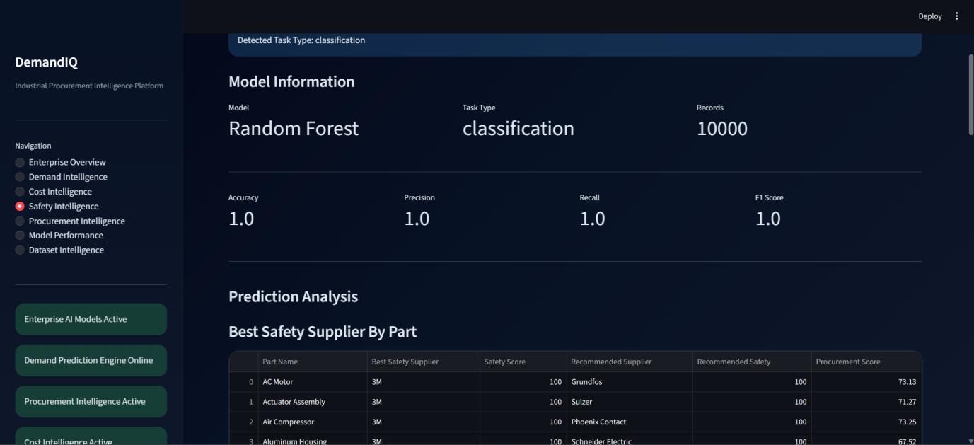
Figure 15.4: Safety Intelligence Dashboard

15.5 Procurement Intelligence Page
The Procurement Intelligence page serves as the central decision-support dashboard.
Displayed information includes:
- Procurement Scores
- Recommended Suppliers
- Procurement Situations
- Procurement Modes
- Supplier Competition Analysis
- Supplier Rankings
This page provides final procurement recommendations generated by the platform.
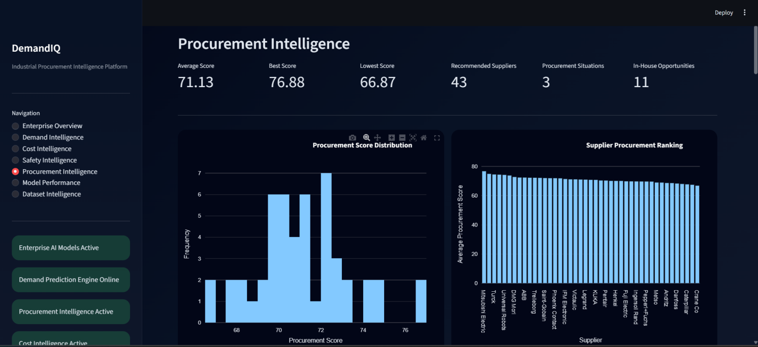
Figure 15.5: Procurement Intelligence Dashboard

15.6 Model Performance Page
The Model Performance page displays the performance of machine learning models used throughout the platform.
Displayed information includes:
- Selected Models
- Model Scores
- R² Metrics
- MAE Metrics
- RMSE Metrics
- MAPE Metrics
- Classification Accuracy
This page helps users evaluate model effectiveness.
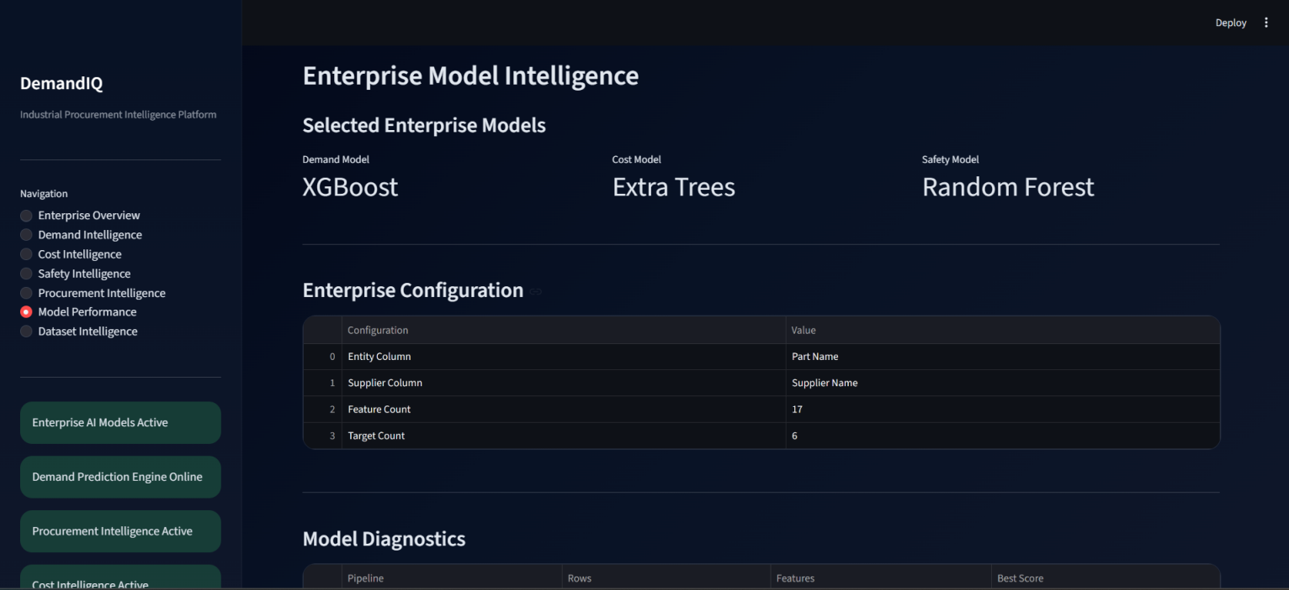
Figure 15.6: Model Intelligence Dashboard

15.7 Dataset Intelligence Page
The Dataset Intelligence page provides insights into dataset quality and structure.
Displayed information includes:
- Dataset Dimensions
- Feature Count
- Target Count
- Missing Value Analysis
- Data Quality Diagnostics
- Dataset Statistics
This page assists users in understanding dataset readiness before analysis.
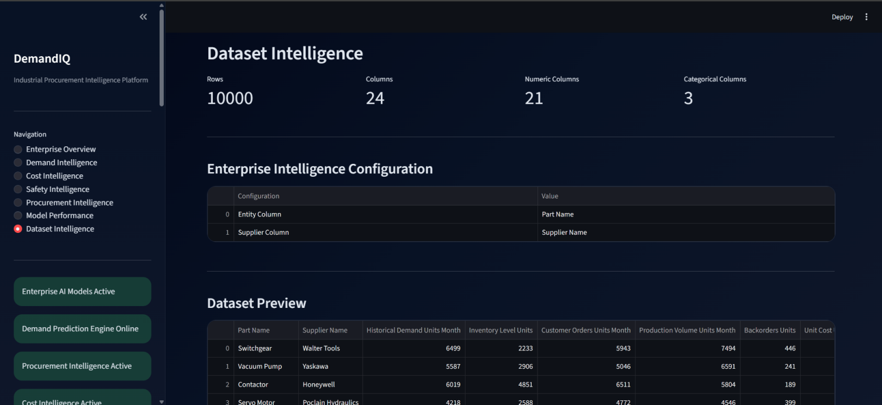

Figure 15.8: Dataset Intelligence Dashboard

16. Reports and Visualizations

16.1 Overview
The Industrial Procurement Intelligence Platform generates interactive reports and visualizations that help users interpret procurement analytics and machine learning outputs. These visualizations support data-driven decision-making by presenting complex procurement information in an easily understandable format.

16.2 Demand Prediction Charts
The Demand Intelligence Module generates visualizations that compare actual and predicted demand values.
Key insights provided include:
- Demand trends
- Demand forecasting patterns
- Prediction accuracy
- Demand distribution
These charts assist procurement teams in inventory planning and demand forecasting.
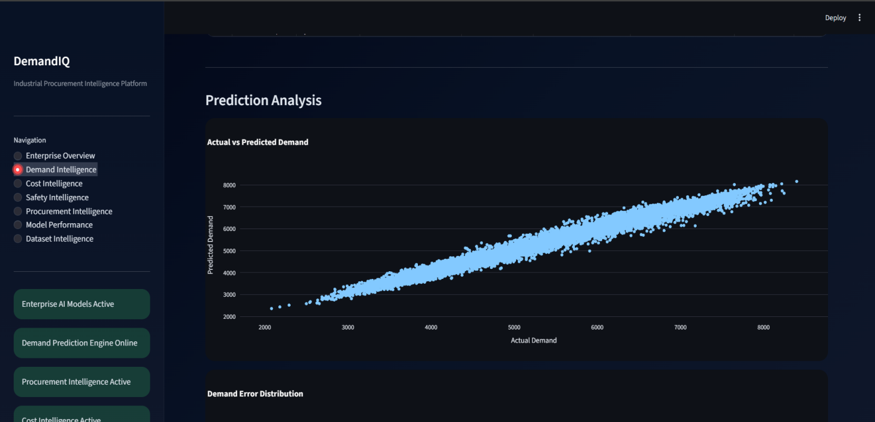
Figure 16.1: Demand Prediction Visualization

16.3 Cost Prediction Charts
The Cost Intelligence Module generates visual representations of procurement cost predictions.
Key insights include:
- Predicted procurement costs
- Cost variations
- Cost forecasting trends
- Cost optimization opportunities
These charts assist organizations in budgeting and procurement planning.
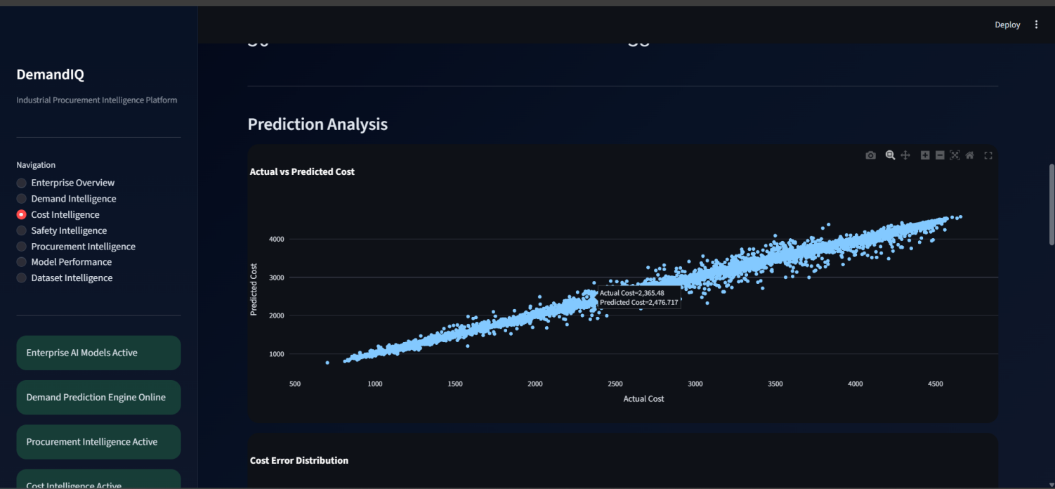
Figure 16.2:Cost Prediction Visualization

16.4 Feature Importance Analysis
Feature importance charts identify the most influential variables affecting procurement predictions.
Benefits include:
- Understanding key procurement drivers
- Model interpretability
- Supplier evaluation support
- Decision-making transparency
The platform generates separate feature importance visualizations for Demand, Cost, and Safety Intelligence modules.
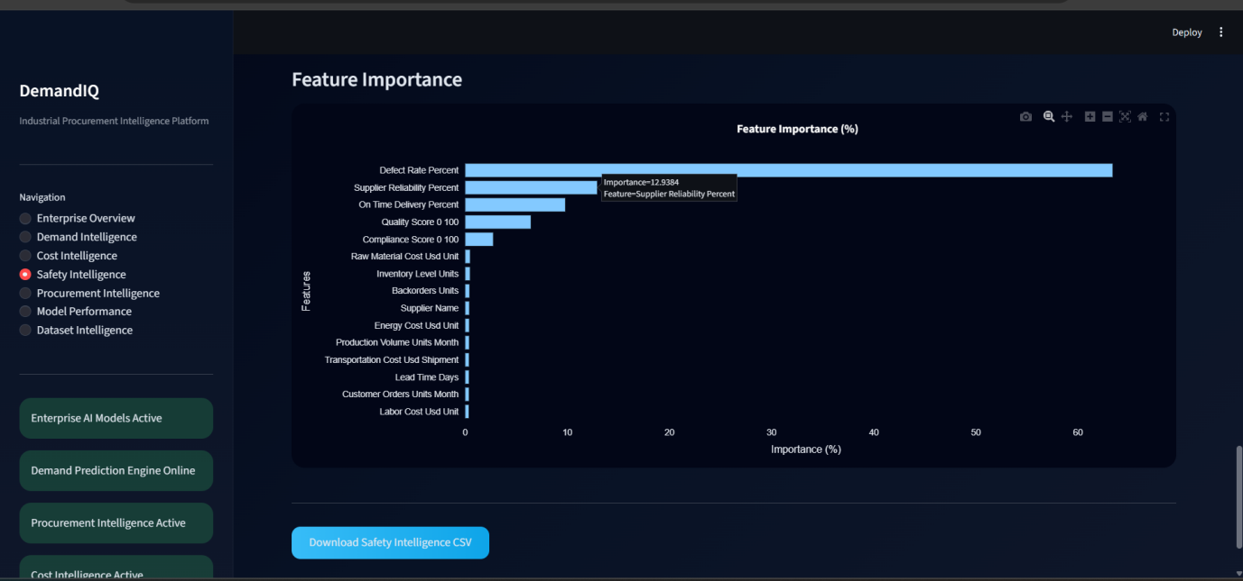
Figure 16.3:Feature Importance Analysis for Safety Model

16.5 Supplier Ranking Analysis
Supplier ranking visualizations compare suppliers based on procurement intelligence scores.
The analysis helps users:
- Identify top-performing suppliers
- Compare supplier competitiveness
- Evaluate procurement performance
- Support supplier selection decisions
Supplier rankings are displayed using interactive bar charts.
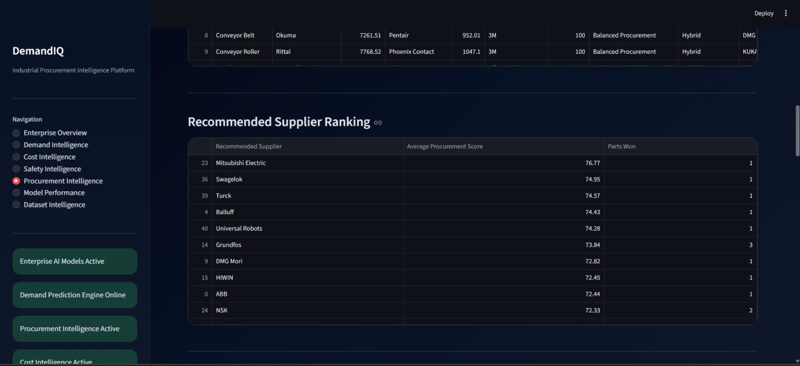
Figure 16.4: Supplier Ranking Analysis

16.6 Procurement Score Distribution
The Procurement Intelligence Module generates procurement score distributions for all evaluated suppliers.
The visualization provides:
- Procurement score frequency
- Supplier performance distribution
- Procurement competitiveness analysis
This helps users understand the overall procurement landscape.
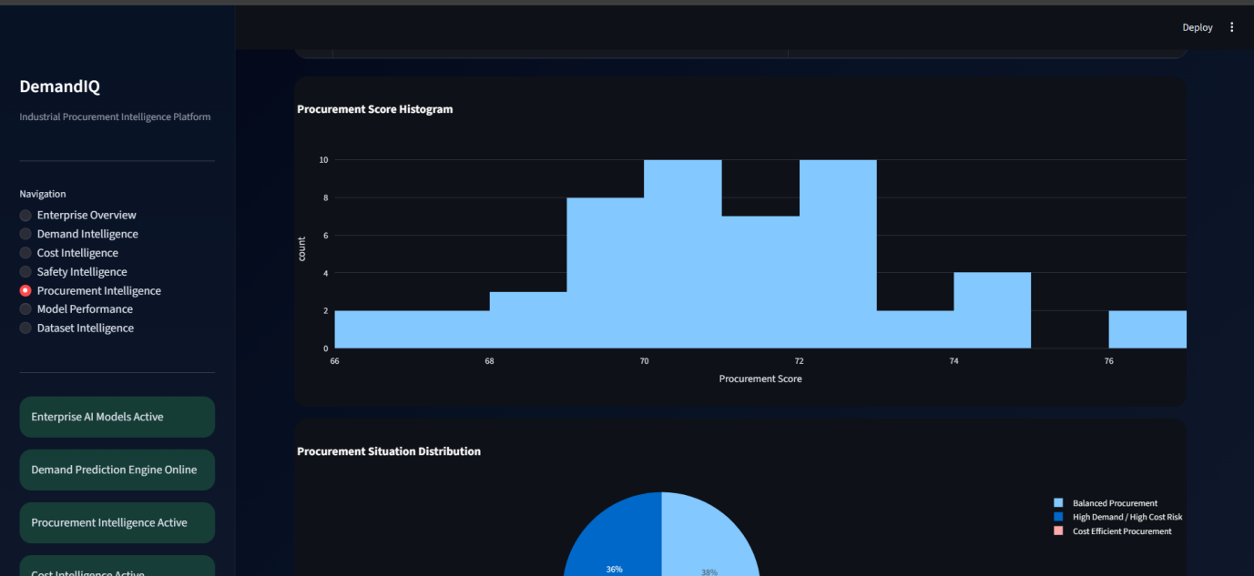
Figure 16.6: Procurement Score Distribution

16.7 Procurement Situation Distribution
Procurement situations identified by the platform are visualized to provide strategic procurement insights.
Common categories include:
- Balanced Procurement
- High Demand / High Cost Risk
- Cost Efficient Procurement
The visualization supports procurement planning and risk assessment.
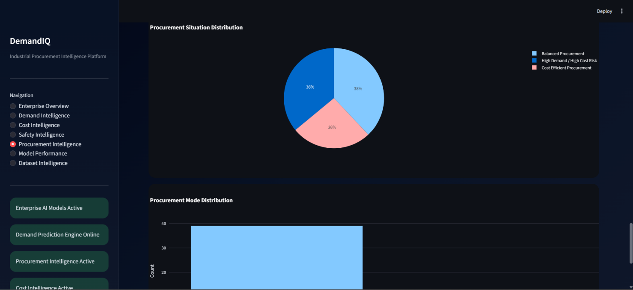
Figure 16.7: Procurement Situation Distribution

16.8 Procurement Mode Distribution
The platform visualizes recommended procurement modes.
Displayed categories include:
- In-House Manufacturing
- External Supplier Procurement
- Hybrid Procurement
This analysis helps organizations optimize procurement strategies.
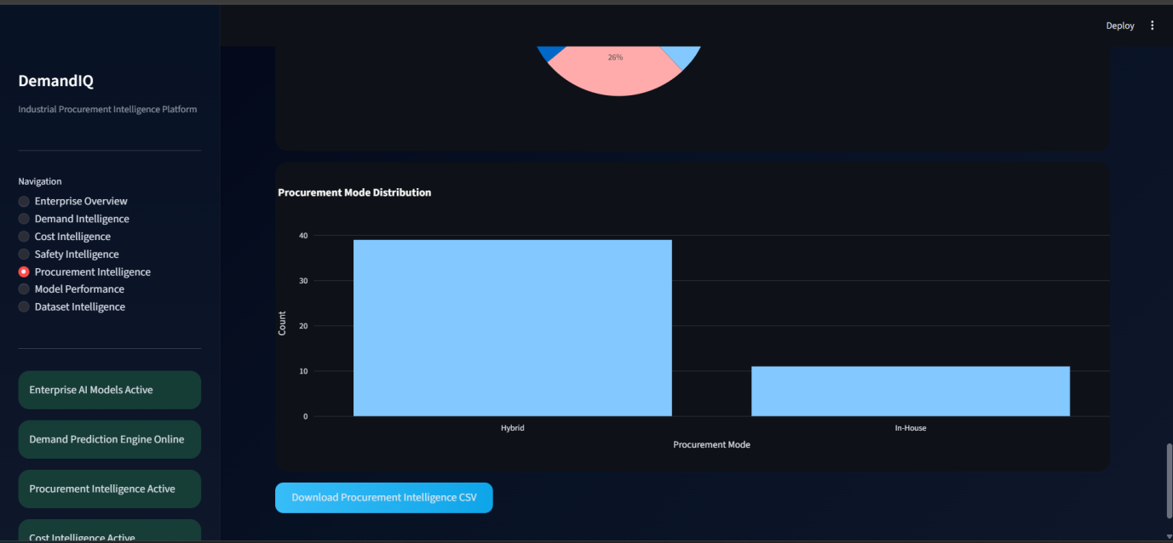
Figure 16.8: Procurement Mode Distribution

16.9 Report Export Capabilities
Generated reports and visualizations can be exported for documentation and analysis purposes.
Exportable outputs include:
- Procurement analytics
- Model performance results
- Supplier rankings
- Procurement recommendations
- Dashboard screenshots

17. GitHub Repository Management

17.1 Repository Setup
The Industrial Procurement Intelligence Platform source code is maintained using Git and GitHub for version control and collaborative development.
The GitHub repository contains:
- Dashboard source code
- Machine learning modules
- Data processing scripts
- Visualization components
- Documentation
Repository initialization is performed using:
git init

17.2 Commit Process
Changes made to the project are recorded using Git commits.
The commit process involves:
git add .
git commit -m "Project Update"
Each commit captures a snapshot of the project at a specific stage of development.

17.3 Push Process
Committed changes are uploaded to the GitHub repository using:
git push origin main
This ensures that the latest project version is stored securely and is available for future deployment.

17.4 Version Control Workflow
The version control workflow followed in the project consists of:
- Modify source code
- Test application functionality
- Stage modified files
- Commit changes
- Push to GitHub
- Verify repository update
This workflow ensures systematic project management and traceability.

17.5 Benefits of GitHub Integration
GitHub integration provides:
- Source code backup
- Version control
- Collaboration support
- Deployment integration
- Project tracking
These features improve development efficiency and project reliability.

18. Deployment Guide

18.1 Deployment Overview
The AI-Powered Enterprise Procurement Intelligence Platform was developed as a Streamlit-based web application and deployed using Streamlit Community Cloud. Deployment enables users to access the application through a web browser without requiring local installation of Python libraries or project dependencies. The deployed application provides centralized access to Demand Intelligence, Cost Intelligence, Safety Intelligence, and Procurement Intelligence modules through a cloud-hosted environment.

18.2 Deployment Prerequisites
Prior to deployment, the following prerequisites must be satisfied:
- A GitHub account for source code management.
- A Streamlit Community Cloud account for application hosting.
- Python development environment configured locally.
- All project source files organized within the project repository.
- A valid requirements.txt file containing project dependencies.
- A runtime.txt file specifying the Python version.
- Verified application functionality through local testing.
- Stable internet connectivity for repository synchronization and deployment.
Meeting these prerequisites ensures a smooth and reliable deployment process.

18.3 GitHub Repository Configuration
GitHub serves as the central source code repository for deployment and version control. The complete project source code, including application modules, preprocessing components, machine learning models, visualization utilities, configuration files, and deployment files, is maintained within a GitHub repository.
The repository structure includes:
- Application source code
- Data preprocessing modules
- Machine learning model components
- Dashboard modules
- Configuration files
- Dependency specifications
- Deployment configuration files
Version control through GitHub enables efficient project maintenance, collaboration, and deployment management.

18.4 Streamlit Community Cloud Deployment
The application was deployed using Streamlit Community Cloud to provide browser-based access to end users.
The deployment process consists of the following steps:
- Create and configure a GitHub repository.
- Upload the complete project source code.
- Verify the availability of requirements.txt and runtime.txt files.
- Log in to Streamlit Community Cloud.
- Connect the GitHub repository.
- Select the deployment branch.
- Specify the application entry point:
dashboard/dashboard.py
- Initiate the deployment process.
- Allow dependency installation and environment configuration.
- Verify successful application startup.
Upon successful deployment, Streamlit generates a public application URL that can be accessed from any supported web browser.

18.5 Deployment Verification
Following deployment, comprehensive verification is performed to ensure proper system operation.
The verification process includes:
- Application accessibility testing.
- User interface validation.
- Dataset upload testing.
- Automated target detection validation.
- Demand Intelligence execution testing.
- Cost Intelligence execution testing.
- Safety Intelligence execution testing.
- Procurement Intelligence execution testing.
- Visualization rendering verification.
- Download functionality verification.
- System responsiveness assessment.
Successful completion of these checks confirms deployment readiness and operational stability.

18.6 Deployment Workflow
The overall deployment workflow of the system is illustrated below:

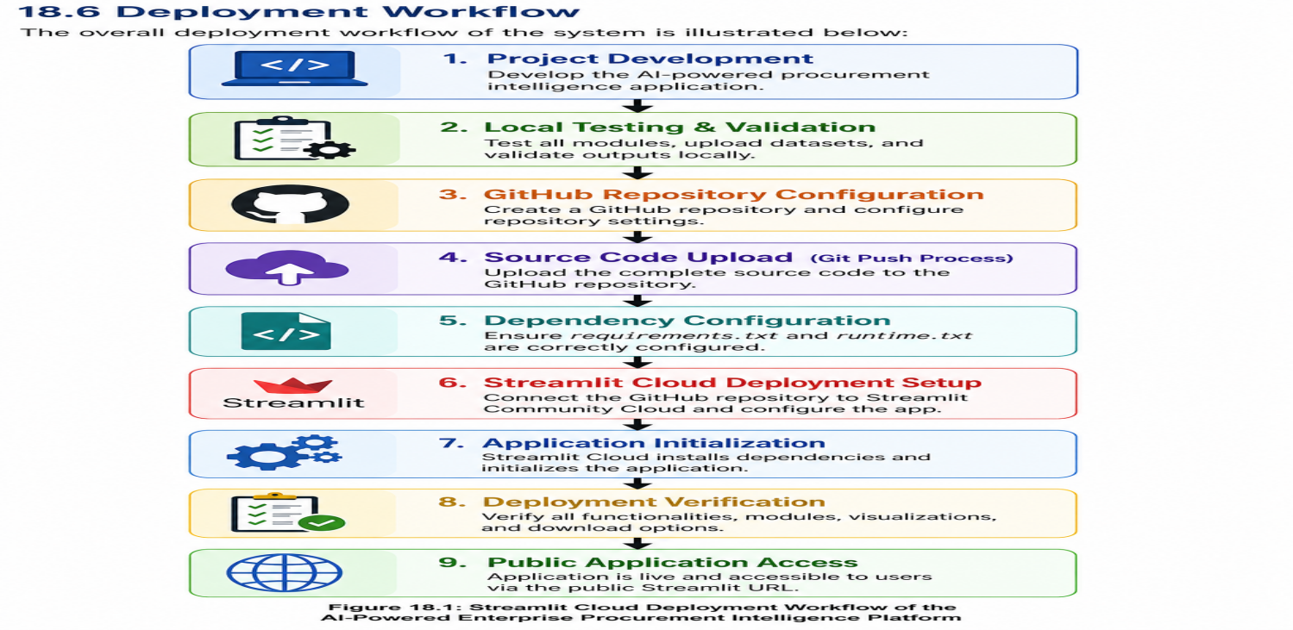
Figure 18.1:Streamlit Cloud Deployment Workflow of the AI-Powered Enterprise Procurement Intelligence Platform
This workflow ensures that the deployed application accurately reflects the validated development version of the platform.

18.7 Post-Deployment Monitoring and Maintenance
Continuous monitoring is essential to maintain application reliability and performance after deployment.
Post-deployment activities include:
- Monitoring application availability.
- Verifying dashboard responsiveness.
- Tracking system performance.
- Reviewing machine learning model execution.
- Monitoring dataset processing efficiency.
- Updating project dependencies when required.
- Applying bug fixes and feature enhancements.
- Maintaining repository synchronization with deployment environments.
Regular monitoring and maintenance ensure long-term operational stability and support future scalability of the platform.

18.8 Deployment Benefits
Deployment of the AI-Powered Enterprise Procurement Intelligence Platform provides several advantages:
- Browser-based accessibility.
- No local software installation requirements.
- Centralized application management.
- Simplified system maintenance.
- Cloud-based availability.
- Enhanced user accessibility.
- Efficient update management through GitHub integration.
- Scalable deployment architecture for future enterprise expansion.
These benefits contribute to the practical usability and adoption of the platform in real-world procurement environments.

19. Troubleshooting

19.1 Application Does Not Launch

Possible Causes
- Python not installed
- Streamlit not installed
- Incorrect project directory

Solution
pip install streamlit
streamlit run dashboard\dashboard.py
Verify Python installation and project location.

19.2 Module Import Errors

Possible Causes
- Missing Python libraries
- Incorrect environment configuration

Solution
Install all required libraries:
pip install -r requirements.txt
Restart the application after installation.

19.3 Dataset Upload Failure

Possible Causes
- Unsupported file format
- Corrupted dataset
- Missing required columns

Solution
- Verify file format (.xlsx)
- Check dataset integrity
- Ensure mandatory procurement fields exist

19.4 Target Detection Failure

Possible Causes
- Unrecognized column names
- Insufficient dataset information

Solution
- Rename columns appropriately
- Manually configure target variables

19.5 Model Training Failure

Possible Causes
- Insufficient data
- Missing target values
- Invalid dataset structure

Solution
- Increase dataset size
- Verify target columns
- Revalidate dataset

19.6 Dashboard Visualization Errors

Possible Causes
- Missing visualization libraries
- Plot rendering issues

Solution
pip install plotly
Restart the application and regenerate the visualization.

19.7 GitHub Push Errors

Possible Causes
- Authentication failure
- Incorrect repository URL
- Network connectivity issues

Solution
- Verify GitHub credentials
- Check repository configuration
- Confirm internet connectivity

19.8 General Support Guidelines
If issues persist:
- Review application logs.
- Verify dataset quality.
- Check dependency installation.
- Restart the application.
- Re-execute the analysis workflow.
Following these steps resolves the majority of operational issues encountered during platform usage.

20. Frequently Asked Questions (FAQs)

Q1. What is the AI-Powered Enterprise Procurement Intelligence Platform?
The AI-Powered Enterprise Procurement Intelligence Platform is a machine learning-based decision support system developed to assist organizations in procurement planning, supplier evaluation, cost optimization, safety assessment, and procurement decision-making. The platform integrates Demand Intelligence, Cost Intelligence, Safety Intelligence, and Procurement Intelligence within a unified dashboard environment to generate actionable procurement insights.

Q2. What is the primary objective of the platform?
The primary objective of the platform is to transform procurement data into meaningful business intelligence through automated machine learning workflows. The system helps organizations improve procurement planning, reduce operational risks, optimize supplier selection, and support strategic procurement decisions.

Q3. What file formats are supported by the application?
The platform supports the following dataset formats:
• CSV (.csv)
• Microsoft Excel (.xlsx)
Users can upload datasets directly through the dashboard interface. The uploaded dataset is automatically validated and prepared for analysis.

Q4. Can the application work with any procurement dataset?
Yes. The platform has been designed to operate with a wide variety of procurement datasets. Automatic preprocessing, target detection, and model selection mechanisms enable the application to adapt to different dataset structures without requiring significant manual configuration.

Q5. Is programming knowledge required to use the platform?
No. The platform has been designed with a user-friendly dashboard interface that allows procurement managers, supply chain analysts, manufacturing engineers, and business users to perform advanced analytics without requiring programming or machine learning expertise.

Q6. What happens after a dataset is uploaded?
After dataset upload, the platform automatically performs:
• Dataset validation
• Missing value analysis
• Duplicate detection
• Data preprocessing
• Automated target detection
• Machine learning model selection
• Intelligence generation
• Dashboard visualization
These processes are executed automatically before procurement recommendations are generated.

Q7. How does Automatic Target Detection work?
The Automated Target Detection Engine analyzes column names, data types, and procurement-related keywords to identify suitable target variables. The system automatically detects demand, cost, safety, and manufacturing-related targets required for intelligence generation.

Q8. Can users manually configure target variables?
Yes. If the automatically detected target variable is not appropriate or multiple candidate columns are available, users may manually select alternative target variables through the dashboard interface.

Q9. What intelligence modules are available in the platform?
The platform consists of four major intelligence modules:
• Demand Intelligence
• Cost Intelligence
• Safety Intelligence
• Procurement Intelligence
Each module performs specialized analysis and contributes to procurement decision-making.

Q10. What is Demand Intelligence?
Demand Intelligence utilizes machine learning models to predict future procurement demand based on historical procurement records and operational data. The generated demand forecasts support inventory planning, supplier coordination, and production scheduling activities.

Q11. What is Cost Intelligence?
Cost Intelligence predicts procurement costs using historical purchasing information and machine learning algorithms. The generated insights help organizations improve budgeting, optimize procurement spending, and identify cost-saving opportunities.

Q12. What is Safety Intelligence?
Safety Intelligence evaluates procurement-related safety information and classifies supplier or procurement risk levels. The module assists organizations in selecting safer suppliers and maintaining compliance with operational safety requirements.

Q13. What is Procurement Intelligence?
Procurement Intelligence integrates outputs from Demand Intelligence, Cost Intelligence, and Safety Intelligence to generate supplier rankings, procurement scores, procurement situations, procurement modes, and supplier recommendations.

Q14. How are suppliers evaluated within the platform?
Suppliers are evaluated based on multiple procurement factors, including:
• Demand fulfillment capability
• Cost efficiency
• Safety performance
• Manufacturing capacity
• Procurement competitiveness
The combined evaluation generates supplier rankings and procurement recommendations.

Q15. What is Procurement Score?
Procurement Score is a composite performance metric generated by combining demand, cost, and safety intelligence outputs. The score represents the overall suitability of a supplier or procurement option and supports procurement decision-making.

Q16. What procurement modes can be recommended by the platform?
The platform can recommend the following procurement modes:
• In-House Procurement
• External Supplier Procurement
• Hybrid Procurement
The recommendation depends on demand requirements, manufacturing capacity, cost considerations, and safety factors.

Q17. What machine learning models are used by the system?
The platform evaluates multiple machine learning algorithms and automatically selects the best-performing model based on performance evaluation metrics. Typical algorithms include Random Forest, Extra Trees, Gradient Boosting, Logistic Regression, and Linear Regression.

Q18. How does the platform select the best model?
The platform trains multiple candidate models and evaluates their performance using standard evaluation metrics. The model achieving the highest performance score is automatically selected for prediction and intelligence generation.

Q19. What performance metrics are used to evaluate machine learning models?
For regression tasks, the platform uses:
• R² Score
• Mean Absolute Error (MAE)
• Root Mean Square Error (RMSE)
• Mean Absolute Percentage Error (MAPE)
For classification tasks, the platform uses:
• Accuracy
• Precision
• Recall
• F1-Score

Q20. What outputs are generated by the platform?
The platform generates:
• Predicted Demand
• Predicted Cost
• Safety Assessment
• Procurement Scores
• Supplier Rankings
• Procurement Situations
• Procurement Modes
• Recommended Suppliers
• Interactive Visualizations
• Downloadable Results

Q21. Can users download generated results?
Yes. The platform provides options to download processed datasets, prediction outputs, procurement intelligence reports, and analytical results for further analysis and documentation.

Q22. Is internet connectivity required to use the application?
The platform supports both local and cloud-based deployment.
For local deployment, internet connectivity is not required after installation.
For cloud deployment through Streamlit Community Cloud, internet connectivity is required to access the application through the public deployment URL.

Q23. Can the application be accessed online?
Yes. The platform has been successfully deployed using Streamlit Community Cloud. Users can access the application through a web browser without installing Python or project dependencies locally.

Q24. Can the platform process large datasets?
Yes. The platform is designed to support large procurement datasets. Processing performance depends on dataset size, available system resources, and deployment environment.

Q25. What should users do if dataset validation fails?
Users should verify that:
• The uploaded file is in CSV or XLSX format.
• Column names are properly defined.
• The dataset contains procurement-related information.
• The file is not corrupted.
After correcting any issues, the dataset may be uploaded again for analysis.

Q26. What should users do if the application becomes unresponsive?
Users should:
- Verify internet connectivity.
- Refresh the dashboard page.
- Re-upload the dataset.
- Restart the application if using local deployment.
- Review dataset quality and size.
These steps resolve most common operational issues.

Q27. How secure is the uploaded data?
Uploaded datasets are processed only within the active application environment. For enterprise deployment scenarios, additional security features such as authentication, authorization, encrypted communication, and role-based access control can be integrated.

Q28. Can the platform be integrated with enterprise systems?
Yes. The platform architecture supports future integration with ERP systems, SAP, Oracle Procurement Cloud, supply chain management systems, and enterprise data warehouses.

Q29. What future enhancements are planned for the platform?
Potential future enhancements include:
• Real-Time Procurement Analytics
• ERP and SAP Integration
• Explainable Artificial Intelligence (XAI)
• Cloud-Based Data Warehousing
• Advanced Deep Learning Models
• Multi-User Authentication
• Automated Report Generation
• Procurement KPI Monitoring

Q30. What are the key benefits of the AI-Powered Enterprise Procurement Intelligence Platform?
The platform provides:
• Automated Procurement Analysis
• Intelligent Supplier Evaluation
• Demand Prediction
• Cost Prediction
• Safety Assessment
• Procurement Recommendation Generation
• Interactive Dashboards
• Cloud-Based Accessibility
• Downloadable Intelligence Reports
• Data-Driven Procurement Decision Support
These capabilities enable organizations to improve procurement efficiency, reduce operational risks, and make informed strategic procurement decisions.

21. Conclusion
The Industrial Procurement Intelligence Platform was developed to provide a unified, AI-driven solution for procurement analytics and decision support. The platform integrates Demand Intelligence, Cost Intelligence, Safety Intelligence, and Procurement Intelligence within a single interactive dashboard, enabling organizations to make informed procurement decisions based on data-driven insights.
Through the application of machine learning techniques, the platform automates target detection, model selection, prediction generation, supplier evaluation, and procurement recommendation processes. This automation reduces manual effort, improves analytical accuracy, and enhances procurement efficiency.
The system supports procurement professionals by providing demand forecasting, cost estimation, safety assessment, supplier ranking, procurement score calculation, and procurement mode recommendations. Interactive visualizations and dashboard analytics further assist users in understanding procurement performance and identifying optimization opportunities.
The modular architecture of the platform ensures scalability, maintainability, and future extensibility. Additional intelligence modules, analytical capabilities, and advanced machine learning models can be incorporated without significantly altering the existing framework.
Overall, the Industrial Procurement Intelligence Platform demonstrates how artificial intelligence and machine learning can be effectively utilized to improve procurement planning, supplier selection, cost management, safety evaluation, and strategic decision-making within modern industrial and manufacturing environments.

Key Achievements
- Automated procurement data analysis
- Demand forecasting using machine learning
- Procurement cost prediction and optimization
- Supplier safety assessment and classification
- Intelligent supplier ranking and recommendation
- Procurement score generation
- Procurement mode recommendation
- Interactive Streamlit-based dashboard
- Automated model selection framework
- Integrated procurement decision-support system

Future Enhancements
Potential future improvements include:
- Real-time procurement analytics
- ERP and SAP integration
- Cloud-based deployment
- Advanced deep learning models
- Automated procurement report generation
- Supplier performance monitoring
- Multi-user access management
- Predictive supply chain analytics
- Procurement chatbot assistance
- Real-time procurement risk monitoring

